Ye servants of the Lord AMNS 150 Melody: Narenza S.M.
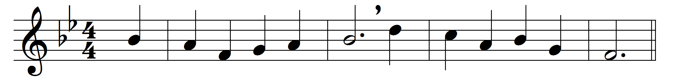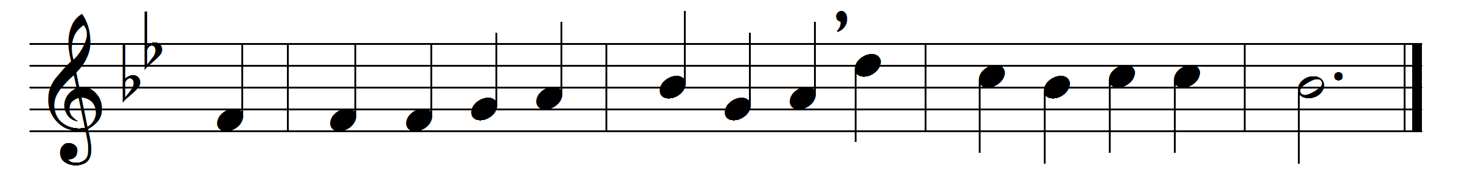

Ye servants of the Lord,
each in his office wait,
observant of his heavenly word,
and watchful at his gate.

Let all your lamps be bright,
and trim the golden flame;
gird up your loins as in his sight,
for aweful is his name.

Watch! ’tis your Lord’s command,
and while we speak, he’s near;
mark the first signal of his hand,
and ready all appear.

O happy servant he
in such a posture found!
he shall his Lord with rapture see,
and be with honour crowned.

Christ shall the banquet spread
with his own royal hand,
and raise that faithful servant’s head
amid the angelic band.

Words: Philip Doddridge (1720-1751)
Music: Adapted from Johann Leisentritt (1527-1586)

