Ye servants of God, your Master proclaim AMNS 149 Melody: Paderborn 10. 10. 11. 11.
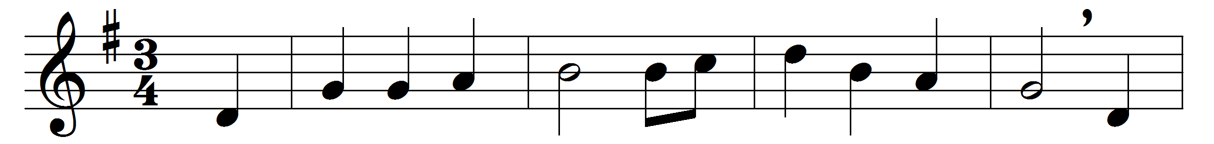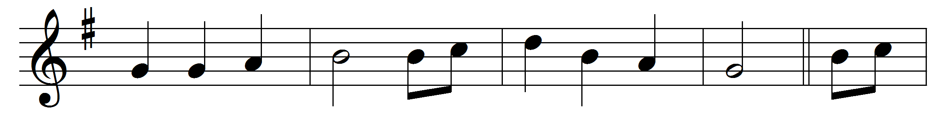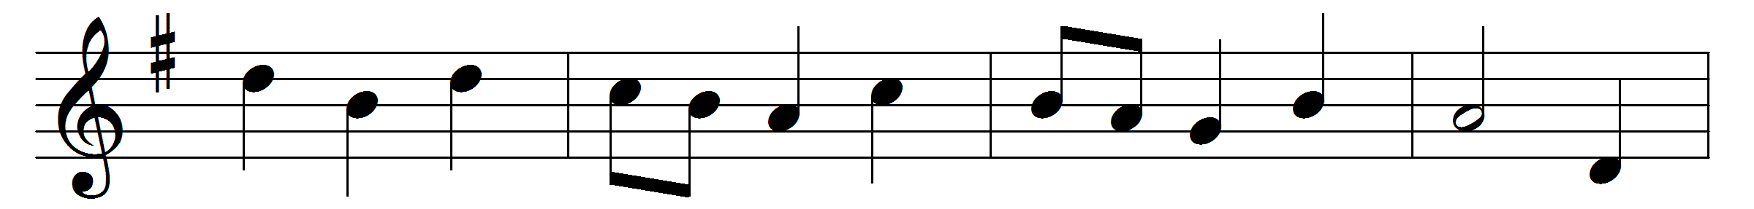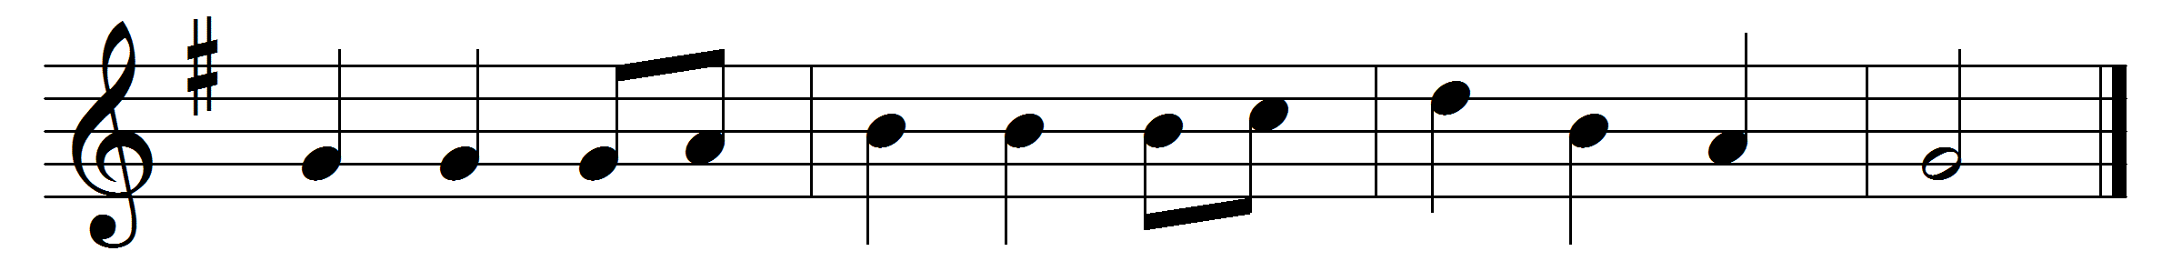

Ye servants of God, your Master proclaim,
and publish abroad his wonderful name;
the name all-victorious of Jesus extol:
his kingdom is glorious, and rules over all.
God ruleth on high, almighty to save;
and still he is nigh: his presence we have;
the great congregation his triumph shall sing,
ascribing salvation to Jesus our King.
Salvation to God who sits on the throne!
let all cry aloud, and honour the Son.
The praises of Jesus the angels proclaim,
fall down on their faces, and worship the Lamb.
Then let us adore, and give him his right:
all glory and power, all wisdom and might,
and honour and blessing, with angels above,
and thanks never-ceasing, and infinite love.

Words: Charles Wesley (1707-1788)
Music: Paderborn Gesangbuch, 1765

