At the name of Jesus AMNS 148 Melody: Evelyns 6 5. 6 5. D.
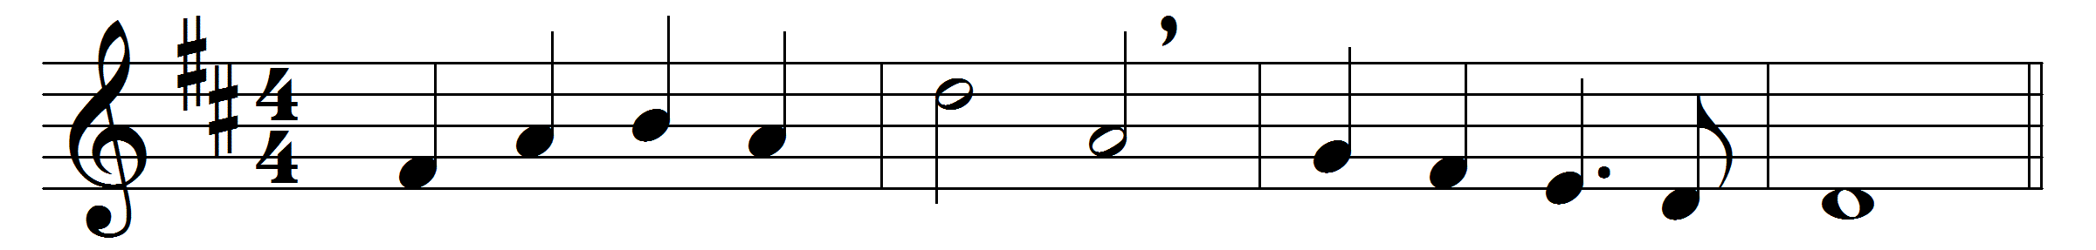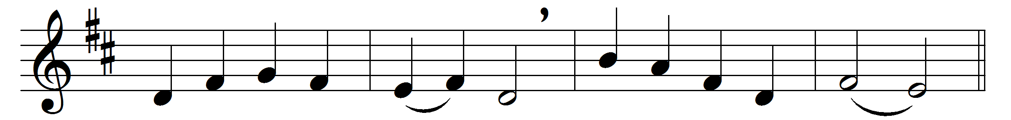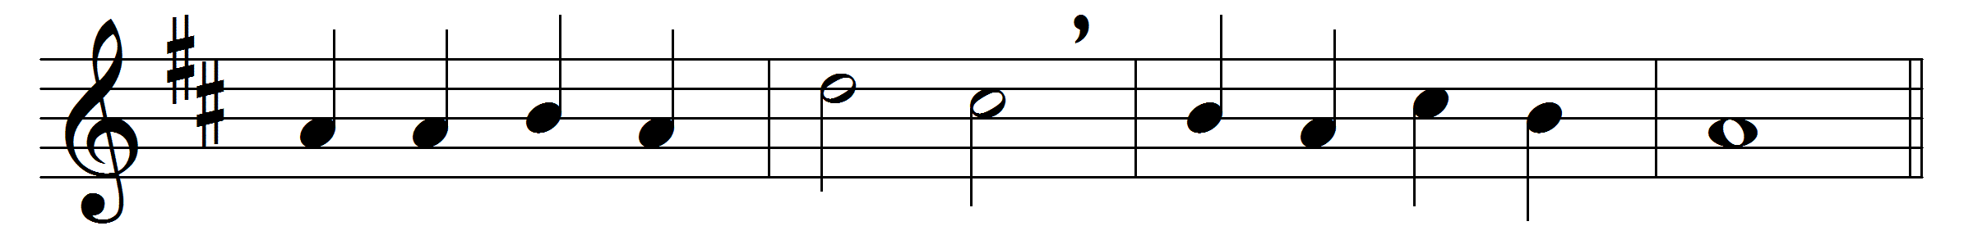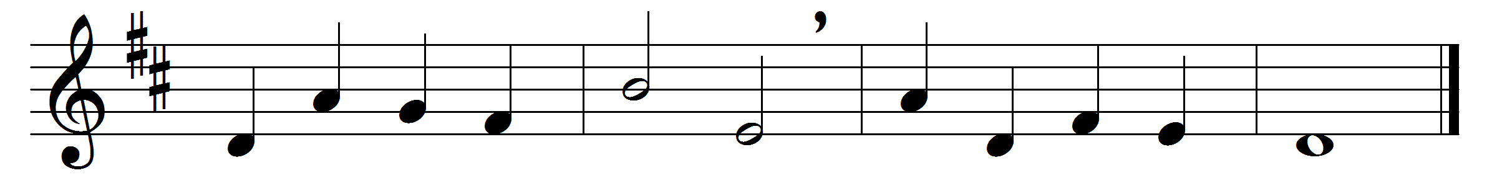
At the name of Jesus
every knee shall bow,
every tongue confess him
King of glory now:
’tis the Father’s pleasure
we should call him Lord,
who from the beginning
was the mighty Word.
At his voice creation
sprang at once to sight,
all the angel faces,
all the hosts of light,
thrones and dominations,
stars upon their way,
all the heavenly orders,
in their great array.
Humbled for a season,
to receive a name
from the lips of sinners
unto whom he came,
faithfully he bore it
spotless to the last,
brought it back victorious,
when from death he passed:
Bore it up triumphant,
with its human light,
through all ranks of creatures,
to the central height,
to the throne of Godhead,
to the Father’s breast;
filled it with the glory
of that perfect rest.
Name him, brothers, name him,
with love strong as death,
but with awe and wonder
and with bated breath:
he is God the Saviour,
he is Christ the Lord,
ever to be worshipped,
trusted, and adored.
In your hearts enthrone him;
there let him subdue
all that is not holy,
all that is not true:
crown him as your Captain
in temptation’s hour;
let his will enfold you
in its light and power.
Brothers, this Lord Jesus
shall return again,
with his Father’s glory,
with his angel train;
for all wreaths of empire
meet upon his brow,
and our hearts confess him
King of glory now.

Words: Caroline Marie Noel (1817-1877)
Music: William Henry Monk (1823-1889)

