Crown him with many crowns AMNS 147 Melody: Diademata D.S.M.
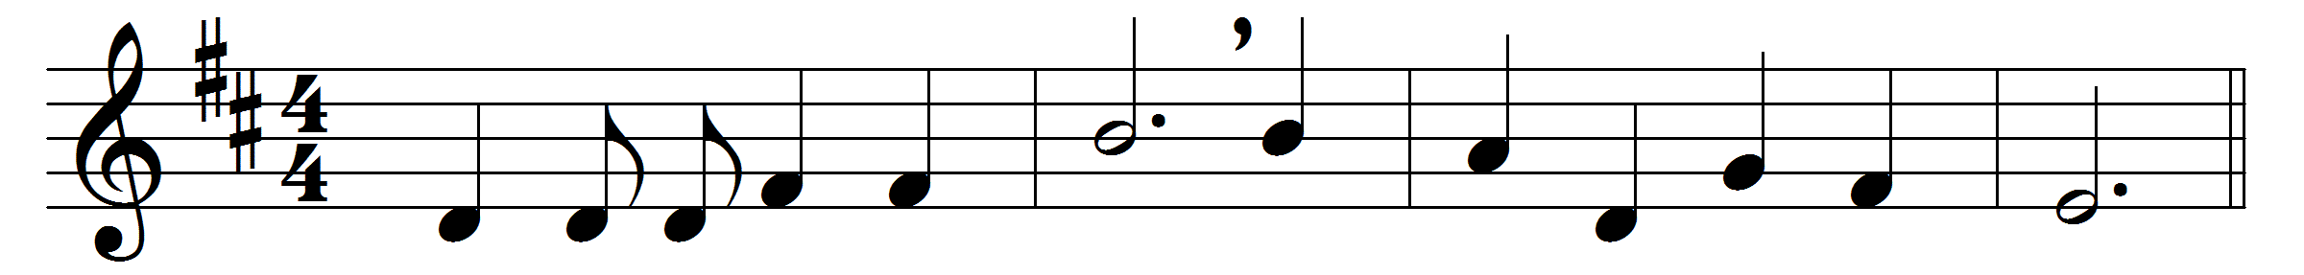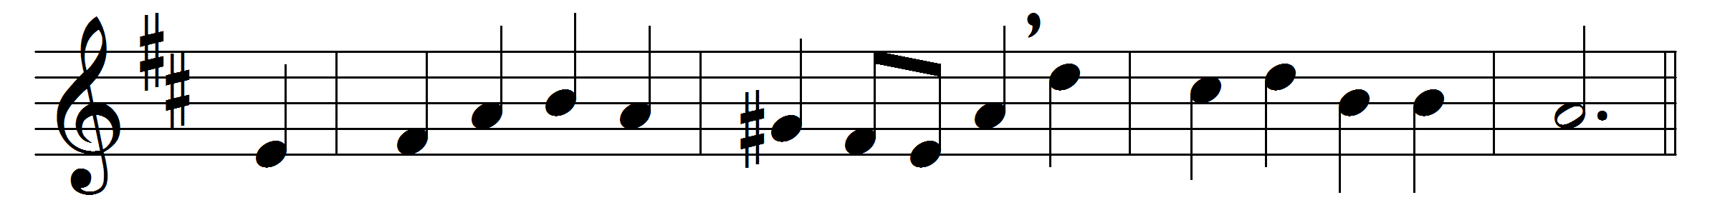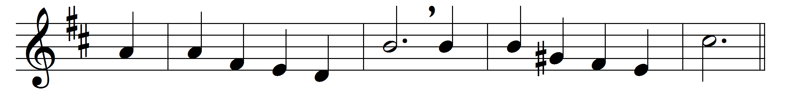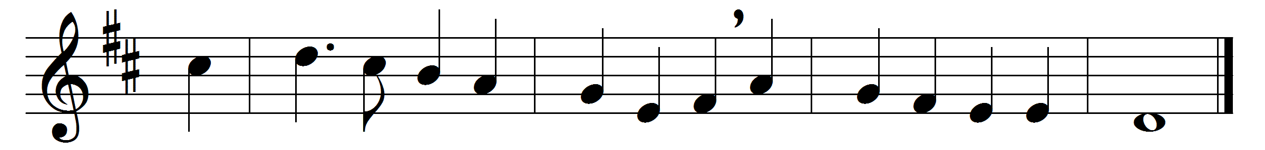

Crown him with many crowns,
the Lamb upon his throne;
hark, how the heavenly anthem drowns
all music but its own:
awake, my soul, and sing
of him who died for thee,
and hail him as thy matchless King
through all eternity.
Crown him the Virgin’s Son,
the God incarnate born,
whose arm those crimson trophies won
which now his brow adorn:
Fruit of the mystic Rose,
as of that Rose the Stem;
the Root whence mercy ever flows,
the Babe of Bethlehem.
Crown him the Lord of love;
behold his hands and side,
those wounds yet visible above
in beauty glorified:
no angel in the sky
can fully bear that sight,
but downward bends his burning eye
at mysteries so bright.
Crown him the Lord of peace,
whose power a sceptre sways
from pole to pole, that wars may cease,
and all be prayer and praise:
his reign shall know no end,
and round his piercèd feet
fair flowers of paradise extend
their fragrance ever sweet.

Crown him the Lord of years,
the Potentate of time,
Creator of the rolling spheres,
ineffably sublime:
all hail, Redeemer, hail!
for thou hast died for me;
thy praise shall never, never fail
throughout eternity.

Words: Matthew Bridges (1800-1894)
Music: George Job Elvey (1816-1893)

