When morning gilds the skies AMNS 146 Melody: Laudes Domini 6 6 6. D.
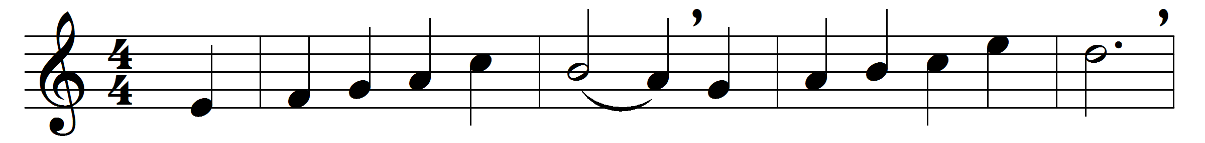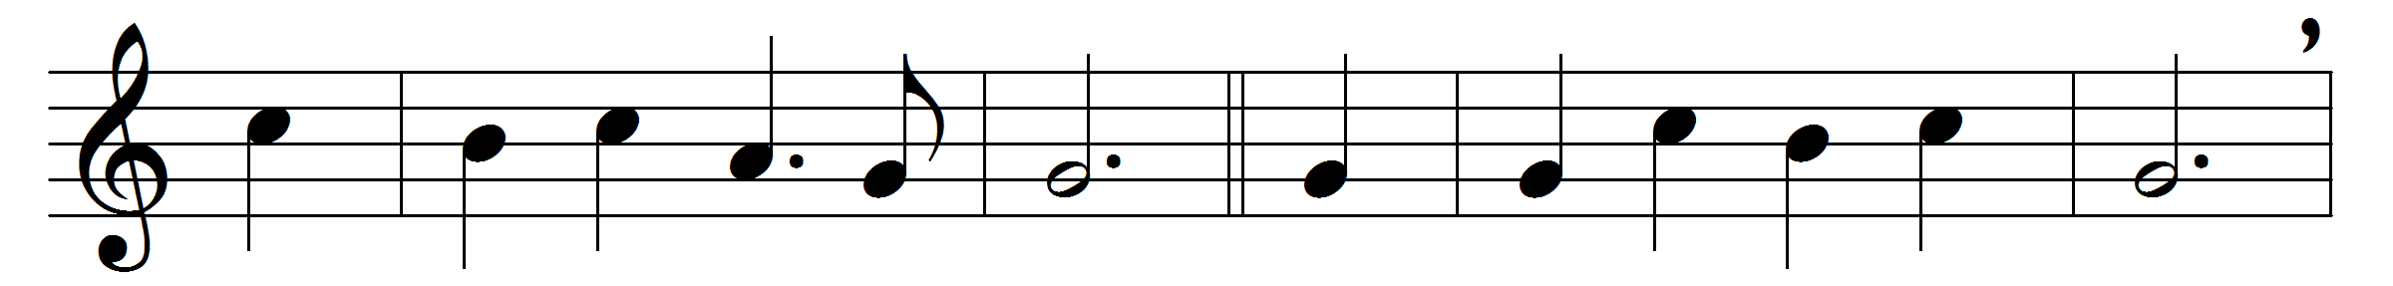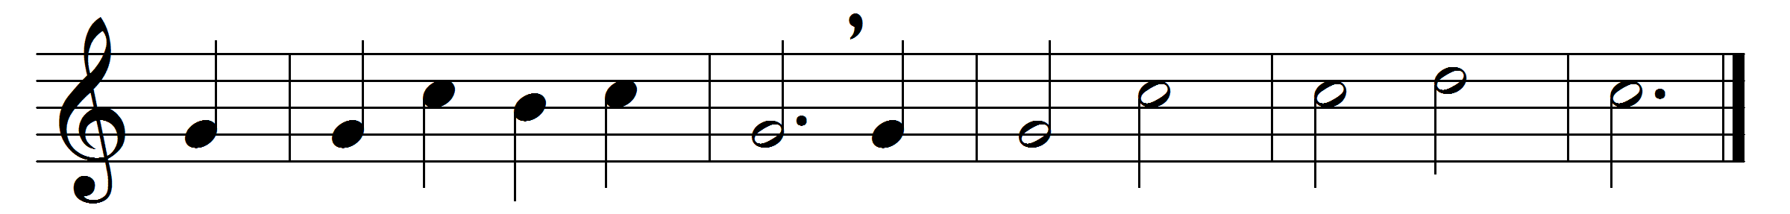

When morning gilds the skies,
my heart awaking cries,
may Jesus Christ be praised:
alike at work and prayer
to Jesus I repair;
may Jesus Christ be praised.

Whene’er the sweet church bell
peals over hill and dell,
may Jesus Christ be praised:
O hark to what it sings,
as joyously it rings,
may Jesus Christ be praised.
My tongue shall never tire
of chanting with the choir,
may Jesus Christ be praised:
this song of sacred joy,
it never seems to cloy,
may Jesus Christ be praised.

Does sadness fill my mind?
a solace here I find,
may Jesus Christ be praised:
or fades my earthly bliss?
my comfort still is this,
may Jesus Christ be praised.
The night becomes as day,
when from the heart we say,
may Jesus Christ be praised:
the powers of darkness fear,
when this sweet chant they hear,
may Jesus Christ be praised.
Be this, while life is mine,
my canticle divine,
may Jesus Christ be praised:
be this the eternal song
through ages all along,
may Jesus Christ be praised.

Words: German, 19th century, translated by Edward Caswall (1814-1878)
Music: Joseph Barnby (1838-1896)

