Jesus shall reign where’er the sun AMNS 143 Melody: Galilee L.M.
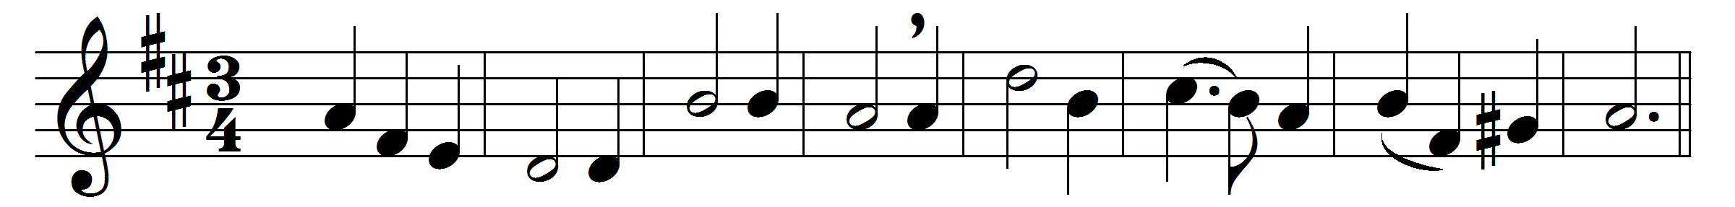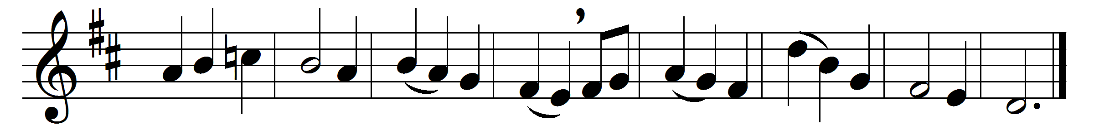

Jesus shall reign where’er the sun
does his successive journeys run;
his kingdom stretch from shore to shore,
till moons shall wax and wane no more.
People and realms of every tongue
dwell on his love with sweetest song,
and infant voices shall proclaim
their early blessings on his name.
Blessings abound where’er he reigns:
the prisoner leaps to lose his chains;
the weary find eternal rest,
and all the sons of want are blest.
To him shall endless prayer be made,
and praises throng to crown his head;
his name like incense shall arise
with every morning sacrifice.
Let every creature rise and bring
peculiar honours to our King;
angels descend with songs again,
and earth repeat the loud Amen.

Words: Isaac Watts (1674-1748)
Music: Philip Armes (1836-1908)

