All hail the power of Jesus’ name! AMNS 140 Melody: Ladywell D.C.M.
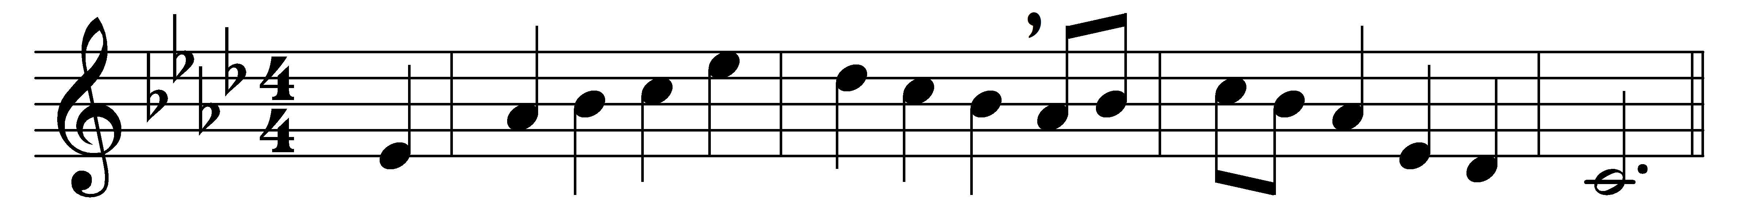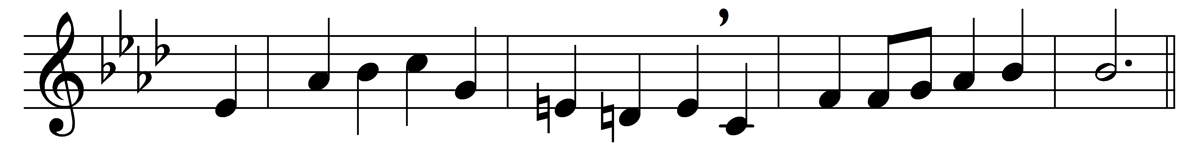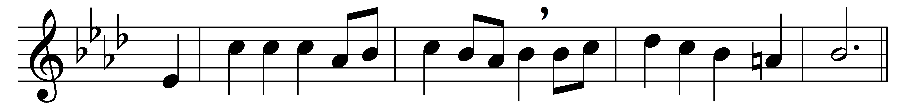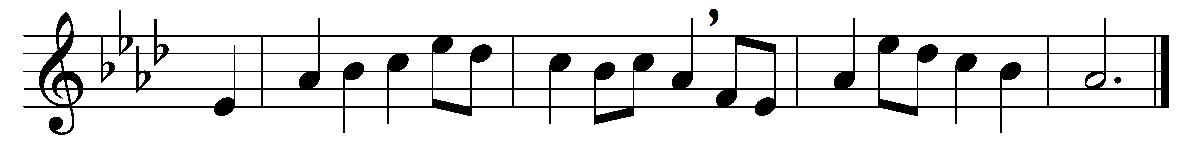

All hail the power of Jesus’ name!
let angels prostrate fall;
bring forth the royal diadem
and crown him Lord of all.

Crown him, ye morning stars of light,
who fixed this floating ball;
now hail the Strength of Israel’s might,
and crown him Lord of all.

Crown him, ye martyrs of your God,
who from his altar call;
extol the Stem-of-Jesse’s Rod,
and crown him Lord of all.

Ye seed of Israel’s chosen race,
ye ransomed of the fall,
hail him who saves you by his grace,
and crown him Lord of all.

Sinners, whose love can ne’er forget
the wormwood and the gall,
go spread your trophies at his feet,
and crown him Lord of all.

Let every tribe and every tongue
before him prostrate fall,
and shout in universal song
the crownèd Lord of all.

Words: Edward Perronet (c. 1726-1792)
Music: William Harold Ferguson (1872-1950)

