Immortal Love for ever full AMNS 133 Melody: Bishopthorpe C.M.
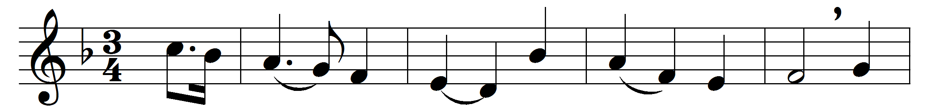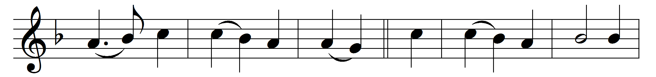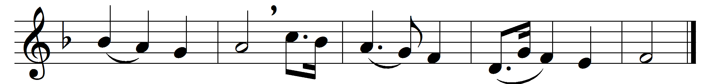

Immortal Love for ever full,
for ever flowing free,
for ever shared, for ever whole,
a never-ebbing sea.

Our outward lips confess the name
all other names above;
love only knoweth whence it came
and comprehendeth love.

We may not climb the heavenly steeps
to bring the Lord Christ down;
in vain we search the lowest deeps,
for him no depths can drown:

but warm, sweet, tender, even yet
a present help is he;
and faith has still its Olivet,
and love its Galilee.

The healing of his seamless dress
is by our beds of pain;
we touch him in life’s throng and press,
and we are whole again.

Through him the first fond prayers are said
our lips of childhood frame;
the last low whispers of our dead
are burdened with his name.

Alone, O Love ineffable,
thy saving name is given;
to turn aside from thee is hell,
to walk with thee is heaven.

Words: John Greenleaf Whittier (1807-1892)
Music: Melody and bass from Select Portions of the Psalms, H. Gardner (c. 1786)

