Where high the heavenly temple stands AMNS 130 Melody: Wareham L.M.
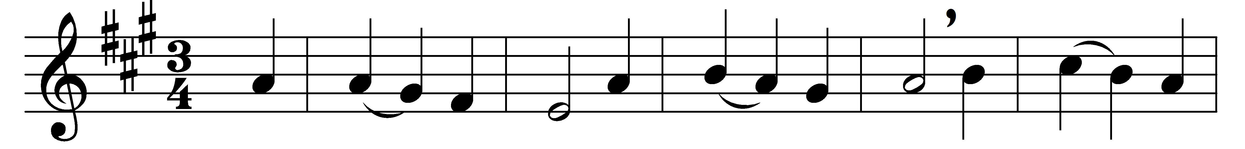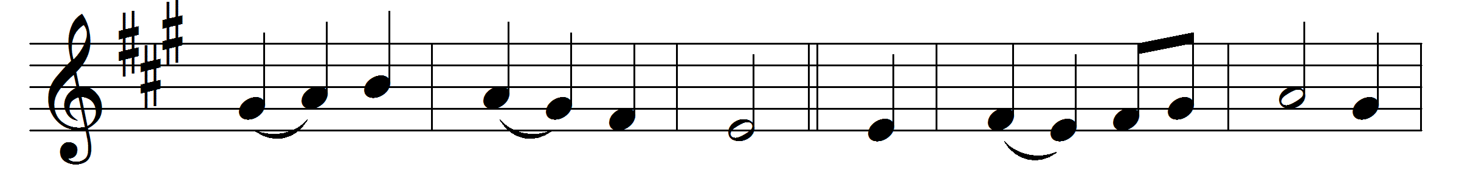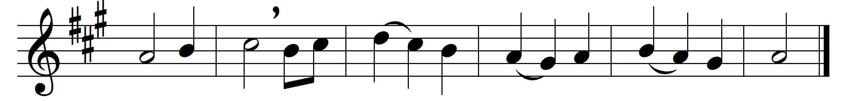

Where high the heavenly temple stands,
the house of God not made with hands,
a great High Priest our nature wears,
the guardian of mankind appears.
He who for men their surety stood,
and poured on earth his precious blood,
pursues in heaven his mighty plan,
the Saviour and the Friend of man.
Though now ascended up on high,
he bends on earth a brother’s eye;
partaker of the human name,
he knows the frailty of our frame.
In every pang that rends the heart
the Man of Sorrows had a part;
he sympathizes with our grief,
and to the sufferer sends relief.
With boldness therefore at the throne
let us make all our sorrows known;
and ask the aid of heavenly power
to help us in the evil hour.

Words: Michael Bruce (1746-1767)
Melody: William Knapp (1698-1768)

