Lord Jesus, think on me AMNS 129 Melody: Southwell (Damon) S.M.
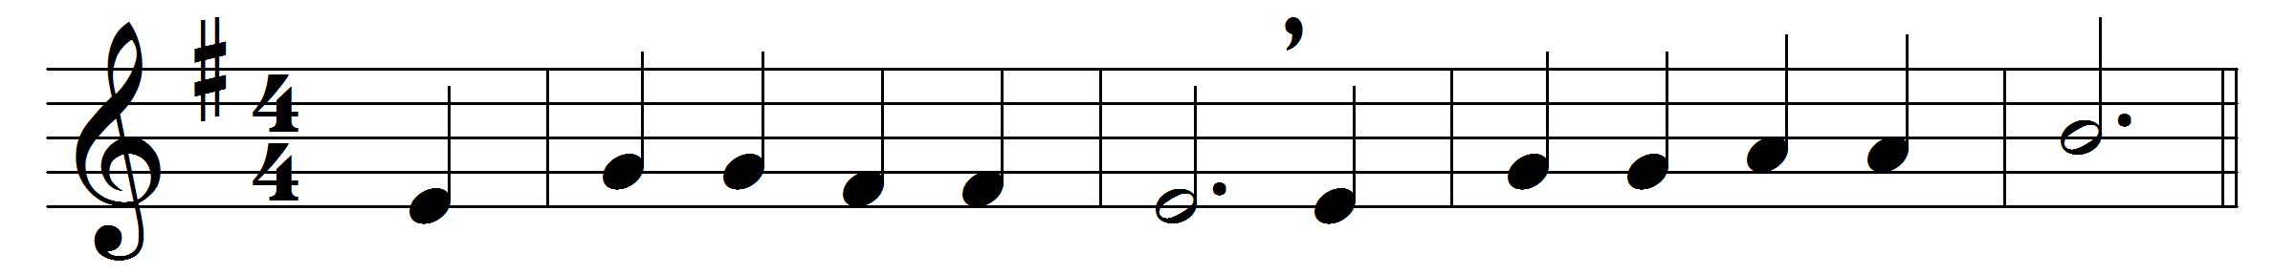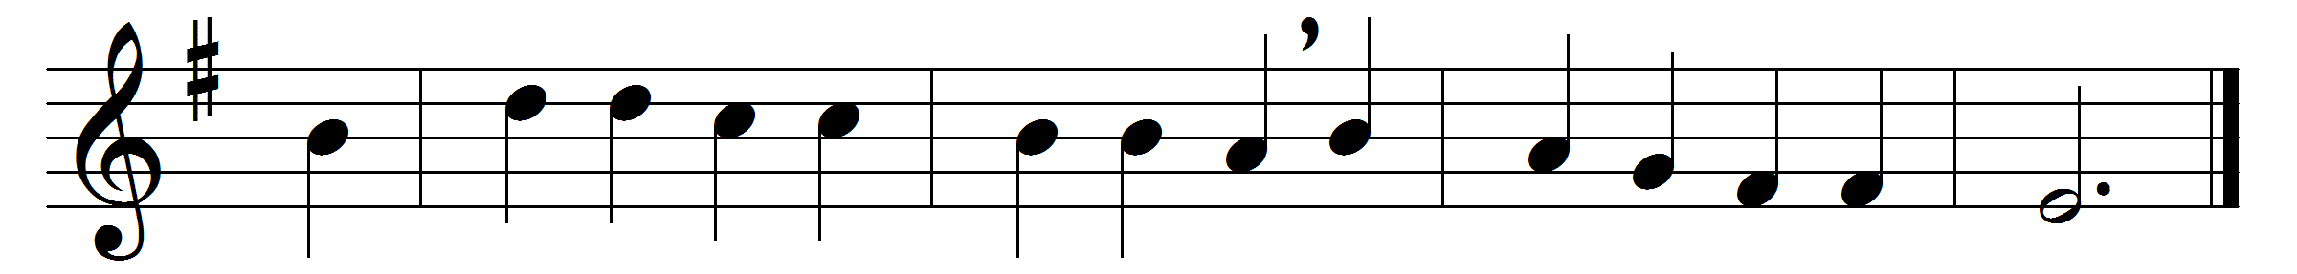

Lord Jesus, think on me,
and purge away my sin;
from earthborn passions set me free,
and make me pure within.
Lord Jesus, think on me
with many a care opprest;
let me thy loving servant be,
and taste thy promised rest.
Lord Jesus, think on me,
nor let me go astray;
through darkness and perplexity
point thou the heavenly way.
Lord Jesus, think on me,
that, when the flood is past,
I may the eternal brightness see,
and share thy joy at last.

Words: Synesius of Cyrene (c. 365-c. 414), translated by Allen William Chatfield (1808-1896)
Music: William Damon (c. 1540-1591)

