To Christ, the Prince of Peace AMNS 127 Melody: St. George S.M.
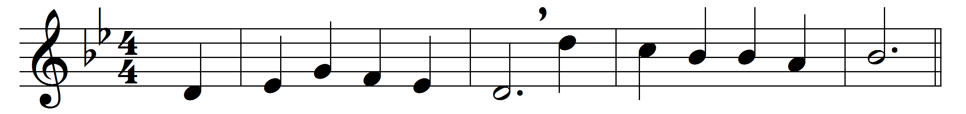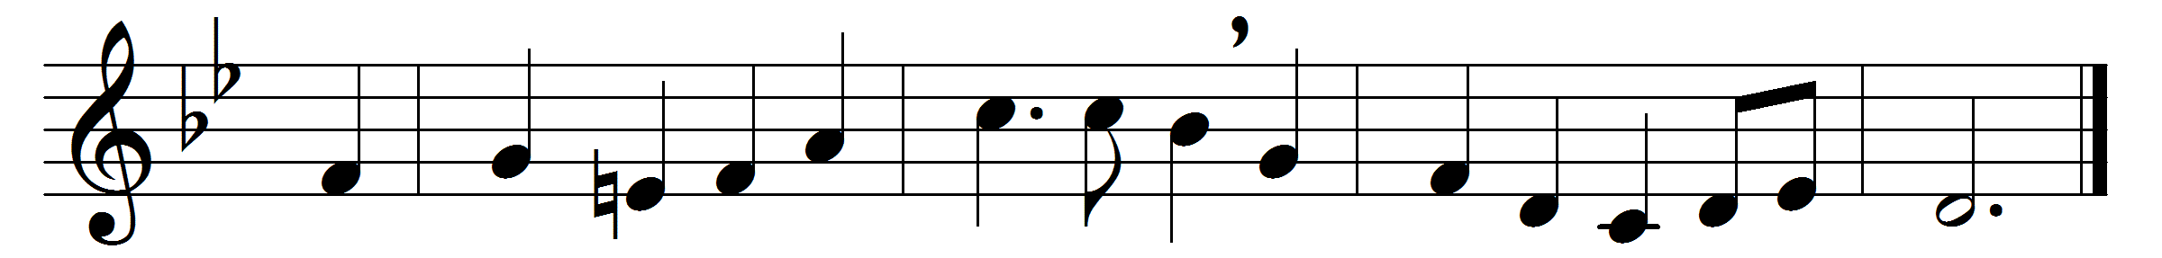

To Christ, the Prince of Peace,
and Son of God most high,
the Father of the world to come,
we lift our joyful cry.
Deep in his heart for us
the wound of love he bore,
that love which he enkindles still
in hearts that him adore.
O Jesu, victim blest,
what else but love divine
could thee constrain to open thus
that sacred heart of thine?
O wondrous fount of love,
O well of waters free,
O heavenly flame, refining fire,
O burning charity!
Hide us in thy dear heart,
Jesu, our Saviour blest,
so shall we find thy plenteous grace,
and heaven’s eternal rest.

Words: Latin, 18th century, translated by Edward Caswall (1814-1878)
Music: Henry John Gauntlett (1805-1876)

