O love divine, how sweet thou art! AMNS 124 Melody: Cornwall 8 8 6. D.
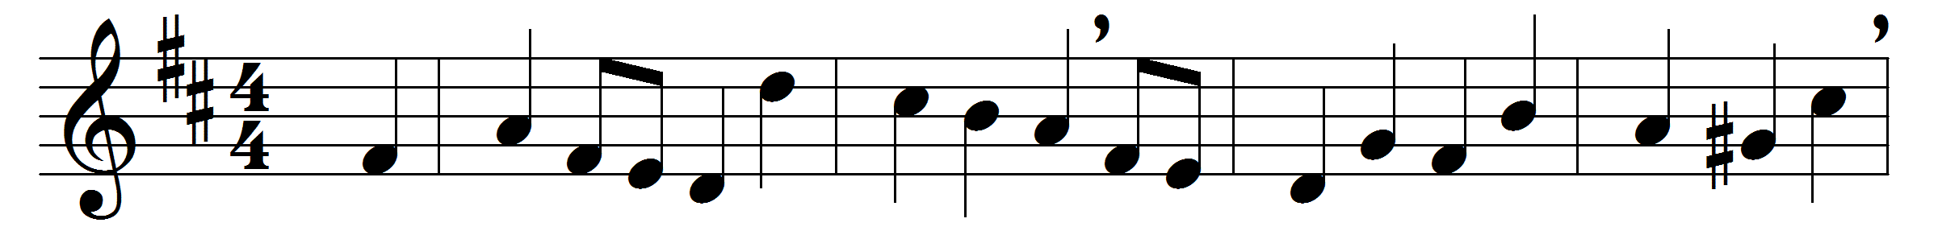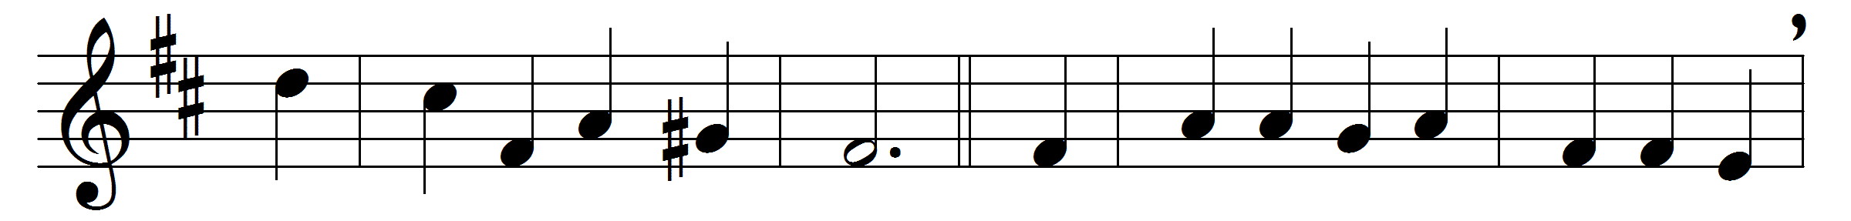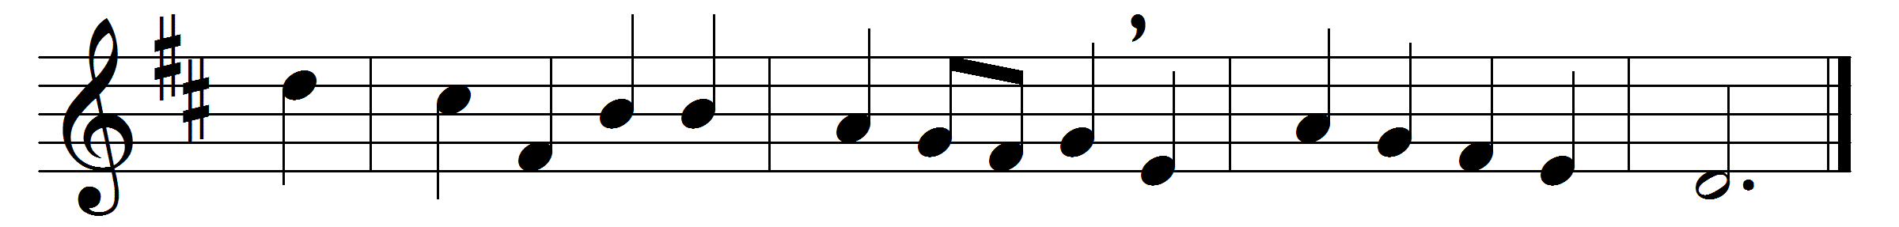

O love divine, how sweet thou art!
When shall I find my longing heart
all taken up by thee?
I thirst, I faint and die to prove
the greatness of redeeming love,
the love of Christ to me.

Stronger his love than death or hell;
its riches are unsearchable:
the first-born sons of light
desire in vain its depth to see;
they cannot reach the mystery,
the length and breadth and height.

God only knows the love of God;
O that it now were shed abroad
in this poor stony heart!
For love I sigh, for love I pine;
this only portion, Lord, be mine,
be mine this better part.

For ever would I take my seat
with Mary at the Master’s feet:
be this my happy choice;
my only care, delight, and bliss,
my joy, my heaven on earth, be this,
to hear the Bridegroom’s voice.

Words: Charles Wesley (1707-1788)
Music: Samuel Sebastian Wesley (1810-1876)

