Jesu, lover of my soul AMNS 123 Melody: Hollingside 7 7. 7 7. D.
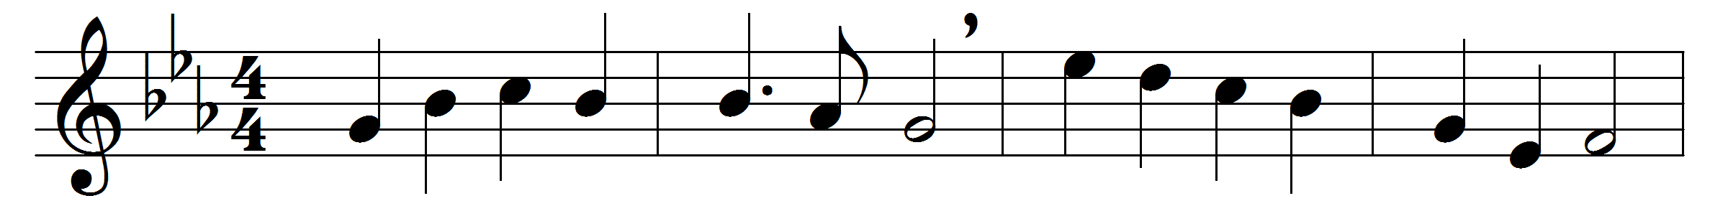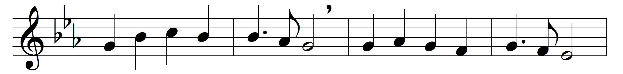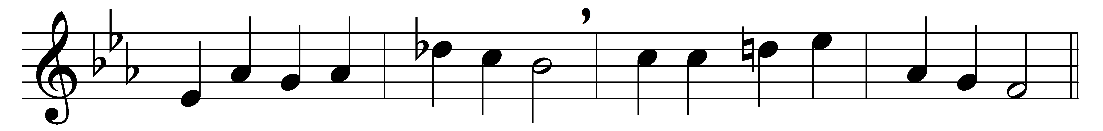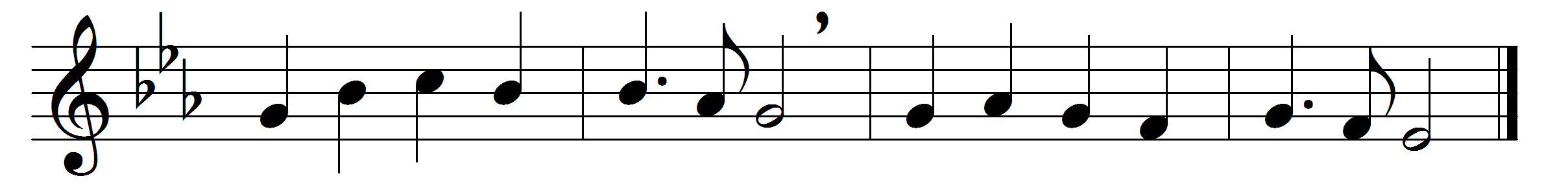

Jesu, lover of my soul,
let me to thy bosom fly,
while the gathering waters roll,
while the tempest still is high:
hide me, O my Saviour, hide,
till the storm of life is past;
safe into the haven guide,
O receive my soul at last.
Other refuge have I none;
hangs my helpless soul on thee;
leave, ah, leave me not alone,
still support and comfort me.
All my trust on thee is stayed,
all my help from thee I bring;
cover my defenceless head
with the shadow of thy wing.
Plenteous grace with thee is found,
grace to cleanse from every sin;
let the healing streams abound;
make and keep me pure within:
thou of life the fountain art;
freely let me take of thee;
spring thou up within my heart,
rise to all eternity.

Words: Charles Wesley (1707-1788)
Music: John Bacchus Dykes (1823-1876)

