How sweet the name of Jesus sounds AMNS 122 Melody: St. Peter C.M.
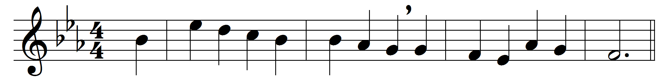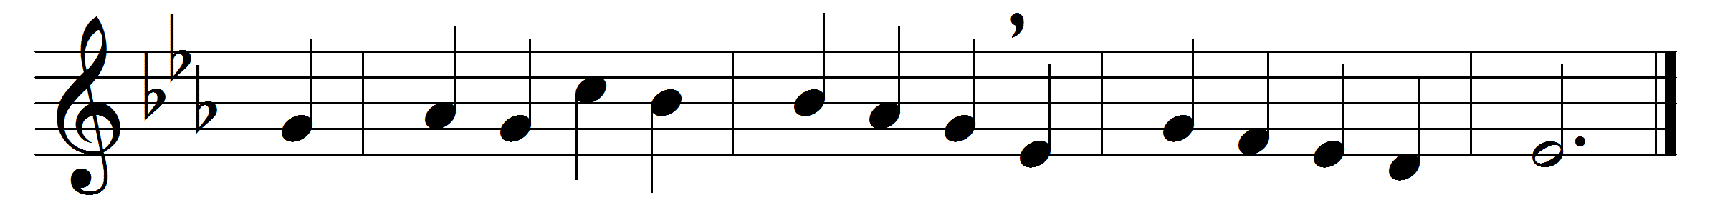

How sweet the name of Jesus sounds
in a believer’s ear!
It soothes his sorrows, heals his wounds,
and drives away his fear.

It makes the wounded spirit whole,
and calms the troubled breast;
’tis manna to the hungry soul,
and to the weary rest.

Dear name! the rock on which I build,
my shield and hiding-place,
my never-failing treasury filled
with boundless stores of grace.

Jesus! my Shepherd, Brother, Friend,
my Prophet, Priest, and King,
my Lord, my Life, my Way, my End,
accept the praise I bring.

Weak is the effort of my heart,
and cold my warmest thought;
but when I see thee as thou art,
I’ll praise thee as I ought.

Till then I would thy love proclaim
with every fleeting breath;
and may the music of thy name
refresh my soul in death.

Words: John Newton (1725-1807)
Music: Alexander Robert Reinagle (1799-1877)

