Firmly I believe and truly AMNS 118 Melody: Halton Holgate 8 7. 8 7.
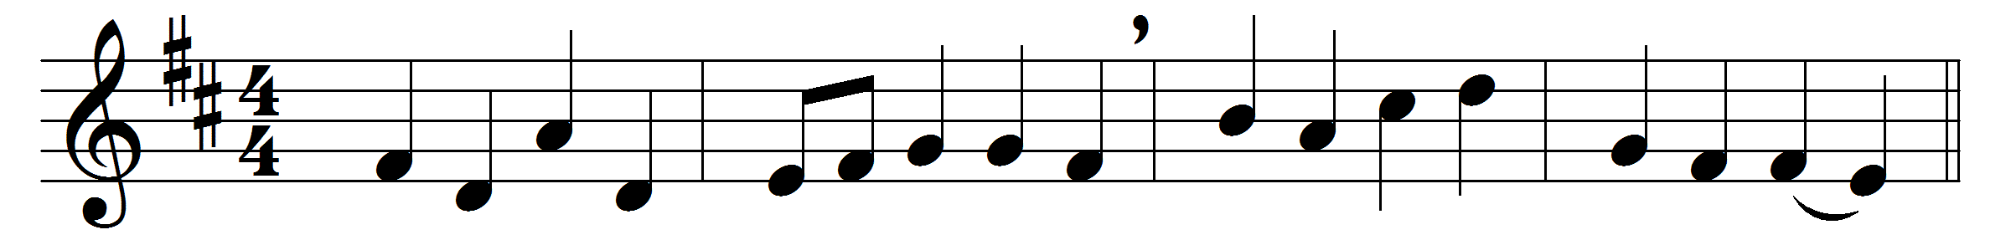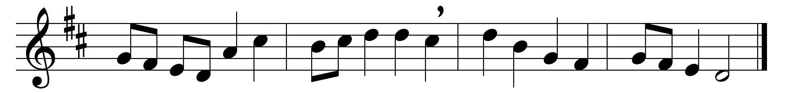

Firmly I believe and truly
God is Three and God is One;
and I next acknowledge duly
Manhood taken by the Son.
And I trust and hope most fully
in that Manhood crucified;
and each thought and deed unruly
do to death, as he has died.
Simply to his grace and wholly
light and life and strength belong,
and I love supremely, solely,
him the holy, him the strong.
And I hold in veneration,
for the love of him alone,
holy Church as his creation,
and her teachings as his own.
Adoration ay be given,
with and through the angelic host,
to the God of earth and heaven,
Father, Son, and Holy Ghost.

Words: John Henry Newman (1801-1890)
Music: Later form of melody by William Boyce (c. 1710-1779)

