All things bright and beautiful AMNS 116 Melody: All things bright and beautiful 7 6. 7 6. with refrain
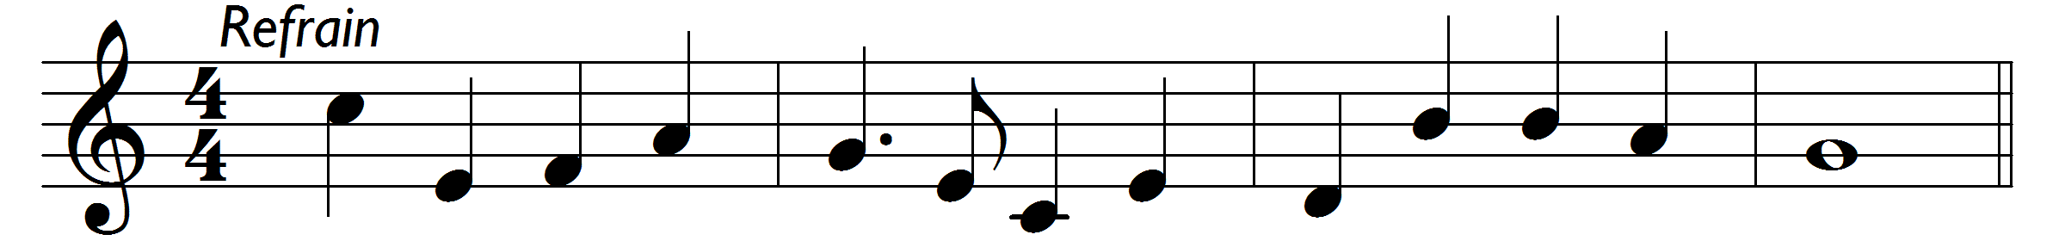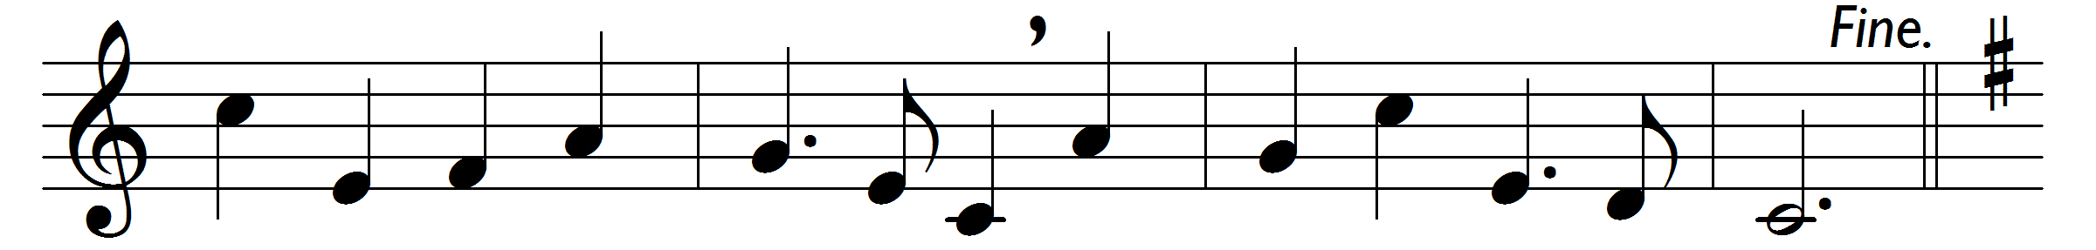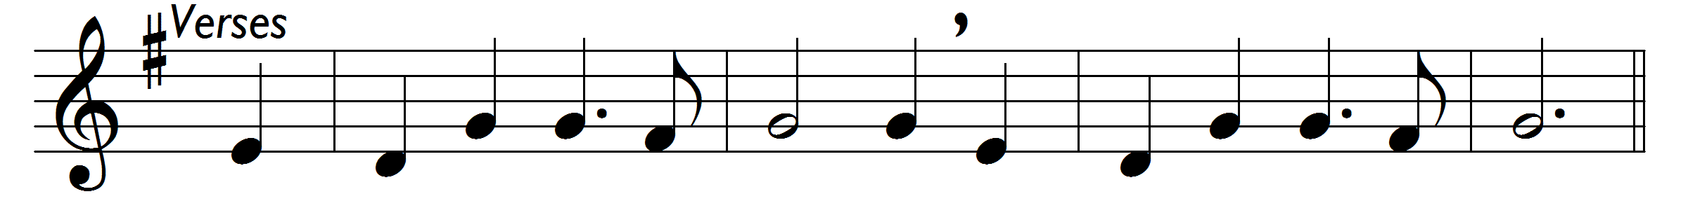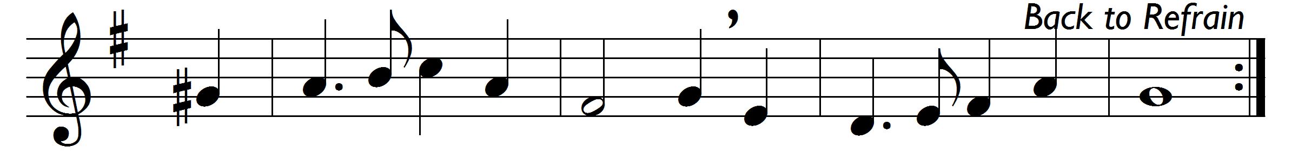

Refrain:
All things bright and beautiful,
all creatures great and small,
all things wise and wonderful,
the Lord God made them all.
Each little flower that opens,
each little bird that sings,
he made their glowing colours,
he made their tiny wings: [Refrain]

The purple-headed mountain,
the river running by,
the sunset, and the morning
that brightens up the sky: [Refrain]

The cold wind in the winter,
the pleasant summer sun,
the ripe fruits in the garden,
he made them every one: [Refrain]

The tall trees in the greenwood,
the meadows where we play,
the rushes by the water
we gather every day: [Refrain]

He gave us eyes to see them,
and lips that we might tell
how great is God almighty,
who has made all things well: [Refrain]

Words: Cecil Frances Alexander (1818-1895)
Music: William Henry Monk (1823-1889)

