A safe stronghold our God is still AMNS 114 Melody: Ein’ feste Burg 8 7. 8 7. 6 6. 6 6 7.
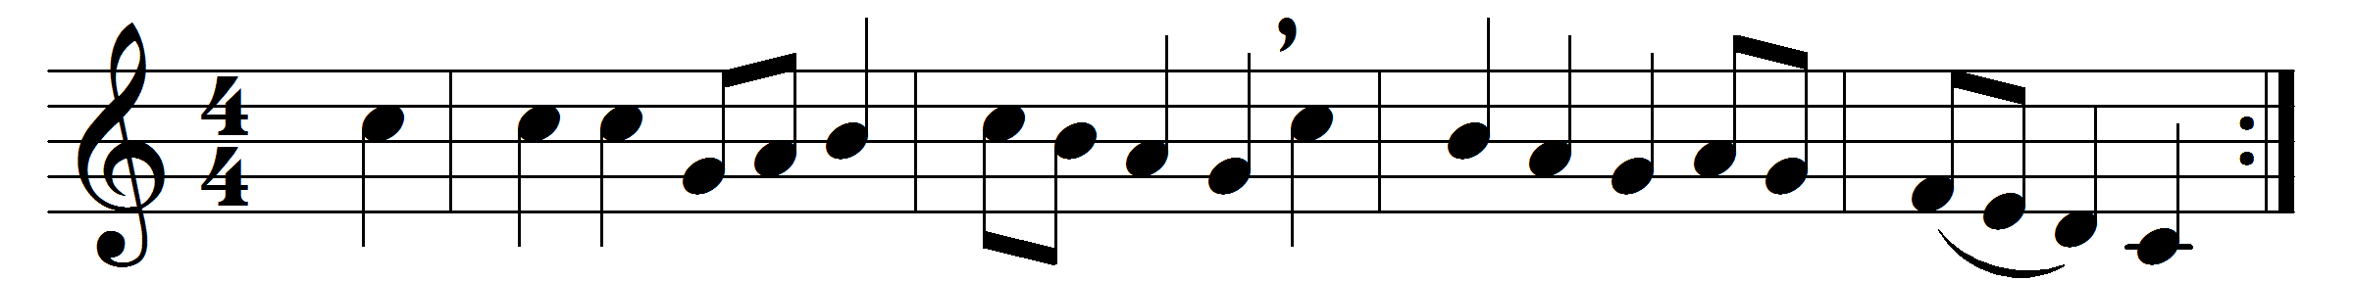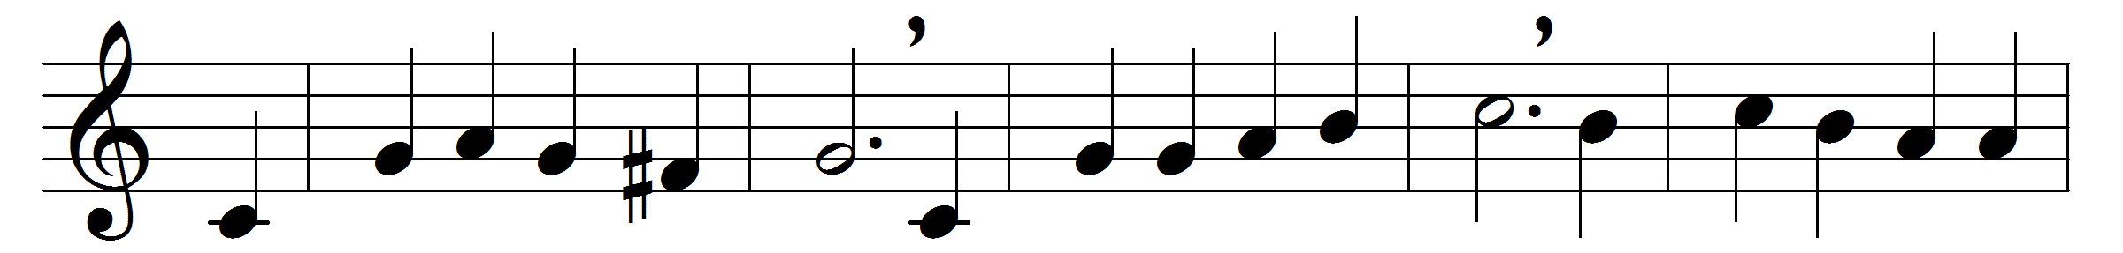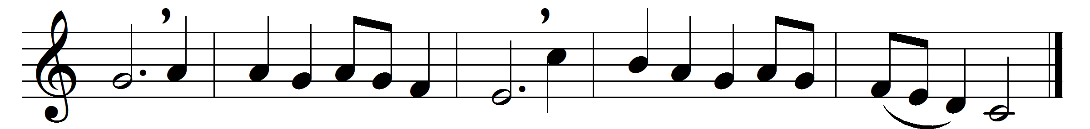

A safe stronghold our God is still,
a trusty shield and weapon;
he’ll keep us clear from all the ill
that hath us now o’ertaken.
The ancient prince of hell
hath risen with purpose fell;
strong mail of craft and power
he weareth in this hour;
on earth is not his fellow.
With force of arms we nothing can,
full soon were we down-ridden;
but for us fights the proper Man,
whom God himself hath bidden.
Ask ye, Who is this same?
Christ Jesus is his name,
the Lord Sabaoth’s Son;
he, and no other one,
shall conquer in the battle.
And were this world all devils o’er,
and watching to devour us,
we lay it not to heart so sore;
not they can overpower us.
And let the prince of ill
look grim as e’er he will,
he harms us not a whit;
for why? his doom is writ;
a word shall quickly slay him.
God’s word, for all their craft and force,
one moment will not linger,
but, spite of hell, shall have its course;
’tis written by his finger.
And though they take our life,
goods, honour, children, wife,
yet is their profit small;
these things shall vanish all:
the City of God remaineth.

Words: Martin Luther (1483-1546), translated by Thomas Carlyle (1795-1881)
Music: Melody by Martin Luther

