The Lord my pasture shall prepare AMNS 111 Melody: Surrey 8 8. 8 8. 8 8.
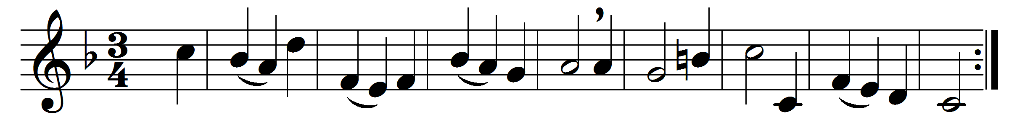

The Lord my pasture shall prepare,
and feed me with a shepherd’s care;
his presence shall my wants supply,
and guard me with a watchful eye;
my noonday walks he shall attend,
and all my midnight hours defend.

When in the sultry glebe I faint,
or on the thirsty mountain pant,
to fertile vales and dewy meads
my weary wandering steps he leads,
where peaceful rivers, soft and slow,
amid the verdant landscape flow.

Though in a bare and rugged way
through devious lonely wilds I stray,
thy bounty shall my pains beguile;
the barren wilderness shall smile
with sudden greens and herbage crowned,
and streams shall murmur all around.

Though in the paths of death I tread,
with gloomy horrors overspread,
my steadfast heart shall fear no ill,
for thou, O Lord, art with me still:
thy friendly crook shall give me aid,
and guide me through the dreadful shade.

Words: Joseph Addison (1672-1719)
Music: Henry Carey (c. 1690-1743)

