Glory to thee, my God, this night AMNS 10 Melody: Tallis’s Canon L.M.
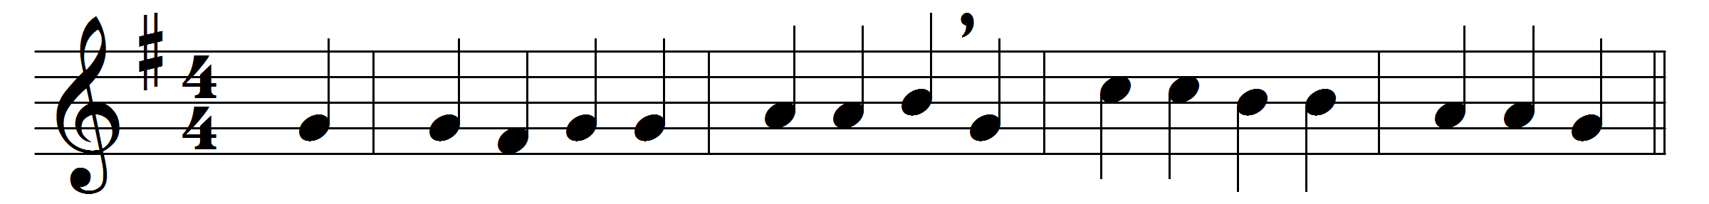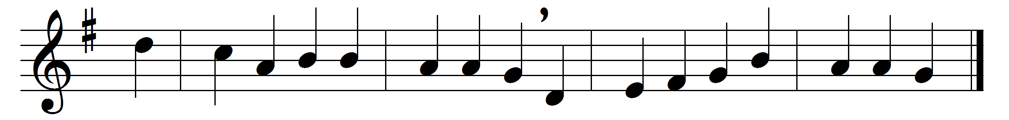

Glory to thee, my God, this night
for all the blessings of the light;
keep me, O keep me, King of kings,
beneath thy own almighty wings.
Forgive me, Lord, for thy dear Son,
the ill that I this day have done,
that with the world, myself, and thee,
I, ere I sleep, at peace may be.
Teach me to live, that I may dread
the grave as little as my bed;
teach me to die, that so I may
rise glorious at the aweful day.
O may my soul on thee repose,
and may sweet sleep mine eyelids close,
sleep that may me more vigorous make
to serve my God when I awake.
When in the night I sleepless lie,
my soul with heavenly thoughts supply;
let no ill dreams disturb my rest,
no powers of darkness me molest.
Praise God, from whom all blessings flow,
praise him, all creatures here below,
praise him above, angelic host,
praise Father, Son, and Holy Ghost.

Words: Thomas Ken (1637-1711)
Music: Thomas Tallis (c. 1505-1585), as shortened by Thomas Ravenscroft (1621)

