Lord of beauty, thine the splendour AMNS 106 Melody: Regent Square 8 7. 8 7. 8 7.
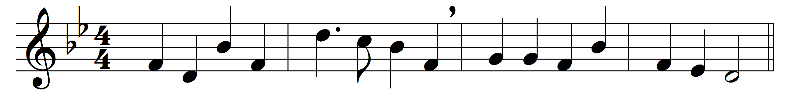
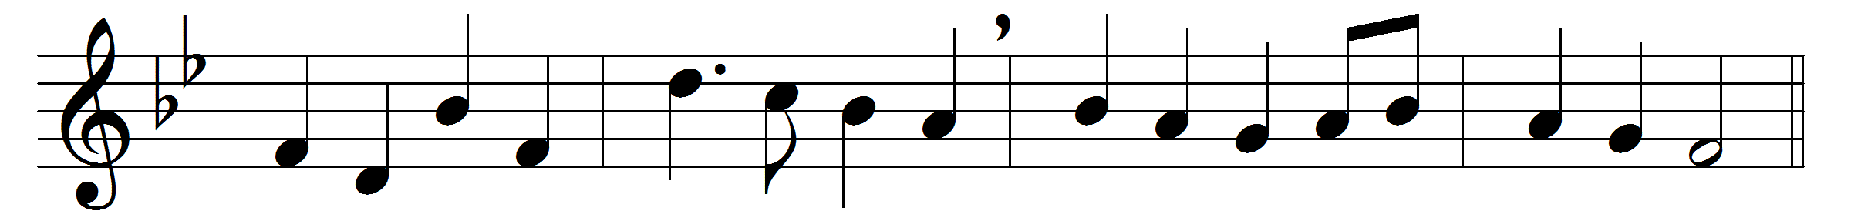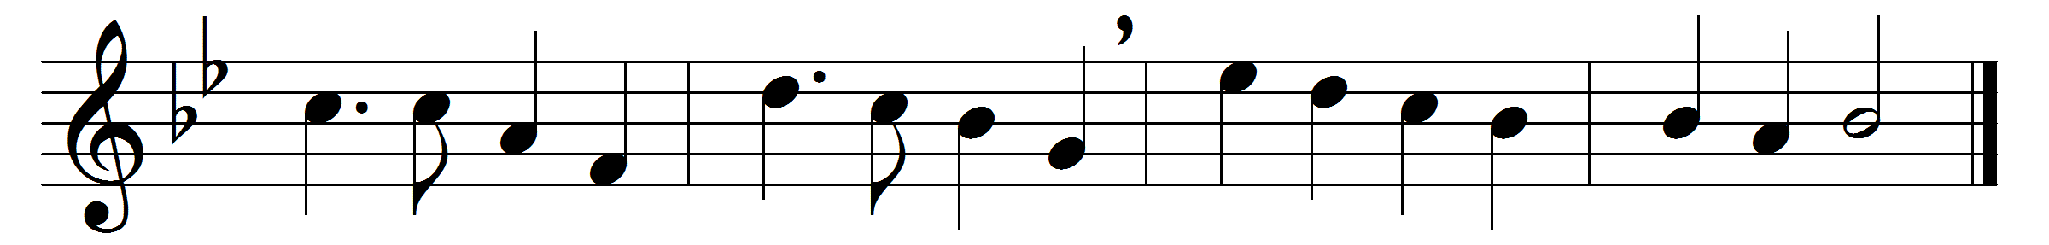

Lord of beauty, thine the splendour
shewn in earth and sky and sea,
burning sun and moonlight tender,
hill and river, flower and tree:
lest we fail our praise to render
touch our eyes that they may see.

Lord of wisdom, whom obeying
mighty waters ebb and flow,
while unhasting, undelaying,
planets on their courses go:
in thy laws thyself displaying,
teach our minds thyself to know.

Lord of life, alone sustaining
all below and all above,
Lord of love, by whose ordaining
sun and stars sublimely move:
in our earthly spirits reigning,
lift our hearts that we may love.

Lord of beauty, bid us own thee,
Lord of truth, our footsteps guide,
till as Love our hearts enthrone thee,
and, with vision purified,
Lord of all, when all have known thee,
thou in all art glorified.

Words: Cyril A. Alington (1872-1955)
Music: Henry Smart (1813-1879)

