Not here for high and holy things Hymnal 1982 no. 9 Melody: Morning Song 86. 86. 86.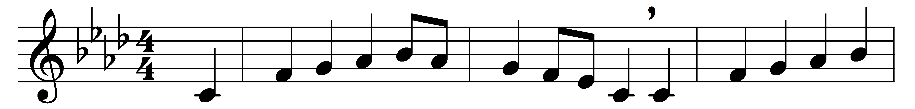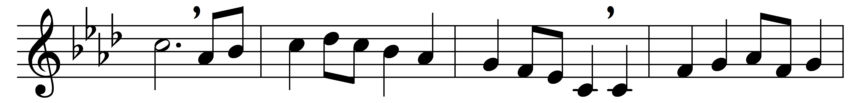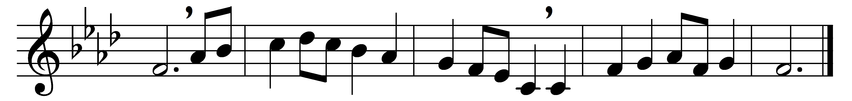

Not here for high and holy things
we render thanks to thee,
but for the common things of earth,
the purple pageantry
of dawning and of dying days,
the splendor of the sea,

the royal robes of autumn moors,
the golden gates of spring,
the velvet of soft summer nights,
the silver glistering
of all the million million stars,
the silent song they sing,

of faith and hope and love undimmed,
undying still through death,
the resurrection of the world,
what time there comes the breath
of dawn that rustles through the trees,
and that clear voice that saith:

Awake, awake to love and work!
The lark is in the sky,
the fields are wet with diamond dew,
the worlds awake to cry
their blessings on the Lord of life,
as he goes meekly by.

Come, let thy voice be one with theirs,
shout with their shout of praise;
see how the giant sun soars up,
great lord of years and days!
So let the love of Jesus come
and set thy soul ablaze,

to give and give, and give again,
what God hath given thee;
to spend thyself nor count the cost;
to serve right gloriously
the God who gave all worlds that are,
and all that are to be.

Words: Geoffrey Anketel Studdert-Kennedy (1883-1929)
Music: Melody attributed to Elkanah Kelsay Dare (1782-1826), harmony by Charles Winfred Douglas (1867-1944)

