Unto us a boy is born! Hymnal 1982 no. 98 Melody: Puer nobis nascitur 7 7. 7 7.
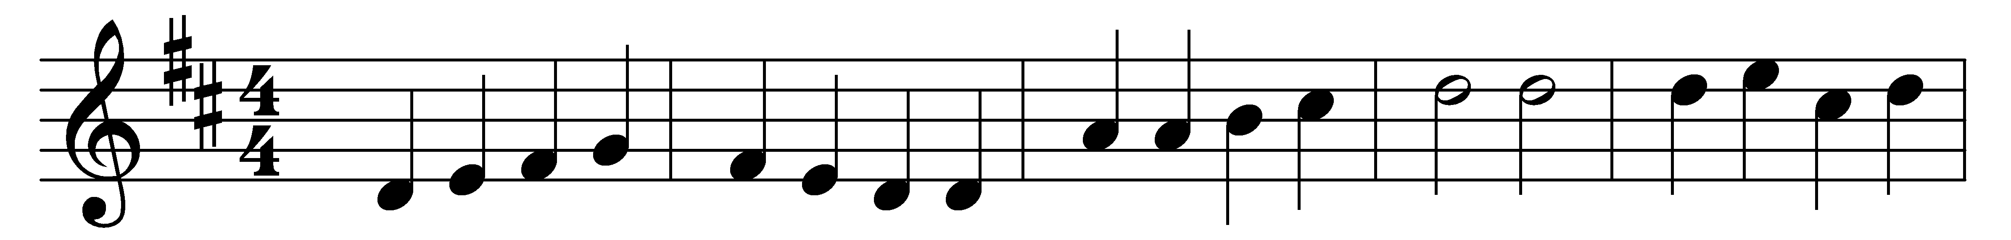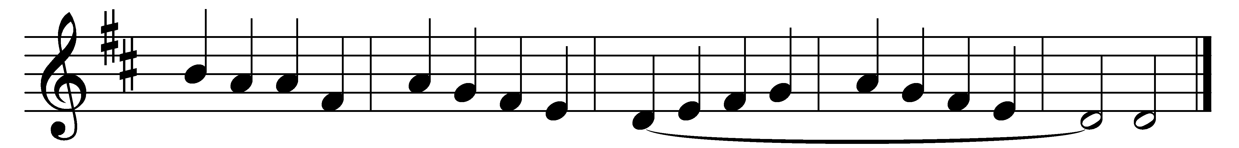

Unto us a boy is born!
The King of all creation,
came he to a world forlorn,
the Lord of every nation.

Cradled in a stall was he
with sleepy cows and asses;
but the very beasts could see
that he all men surpasses.

Herod then with fear was filled;
‘A prince,’ he said, ‘in Jewry!’
All the little boys he killed
at Bethl’hem in his fury.

Now may Mary’s son, who came
so long ago to love us,
lead us all with hearts aflame
unto the joys above us.

Unto us a boy is born!
The King of all creation,
came he to a world forlorn,
the Lord of every nation.

Words: Latin, 15th century, translated by Percy Dearmer (1867-1936)
Music: Melody from Piae Cantiones, 1582, harmonised by Geoffrey Turton Shaw (1879-1943)

