Angels, from the realms of glory Hymnal 1982 no. 93 Melody: Regent Square 8 7. 8 7. 8 7
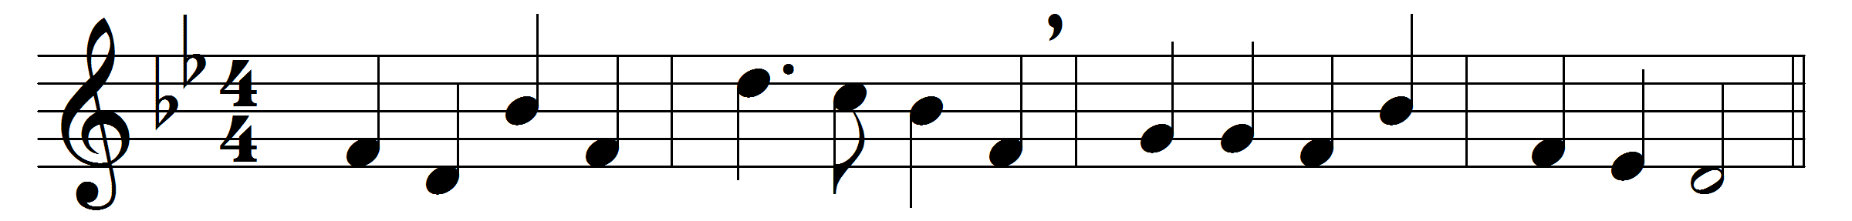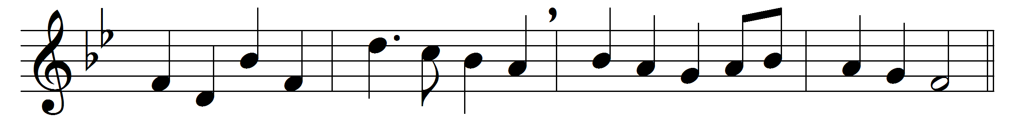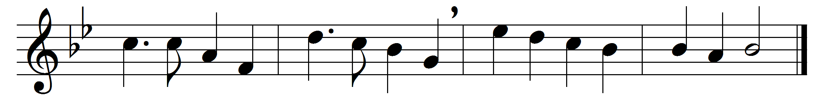

Angels, from the realms of glory,
wing your flight o’er all the earth;
ye, who sang creation’s story,
now proclaim Messiah’s birth:
come and worship, come and worship,
worship Christ, the new-born King.

Shepherds in the field abiding,
watching o’er your flocks by night,
God with you is now residing;
yonder shines the infant Light:
come and worship, come and worship,
worship Christ, the new-born King.

Sages, leave your contemplations;
brighter visions beam afar:
seek the great Desire of nations;
ye have seen his natal star:
come and worship, come and worship,
worship Christ, the new-born King.

Saints before the altar bending,
watching long in hope and fear,
suddenly the Lord, descending,
in his temple shall appear:
come and worship, come and worship,
worship Christ, the new-born King.

Words: James Montgomery (1771-1854)
Music: Henry Smart (1813-1879)

