Sing, O sing, this blessed morn Hymnal 1982 no. 88 Melody: England’s Lane 7 7. 7 7. 7 7.
British spelling
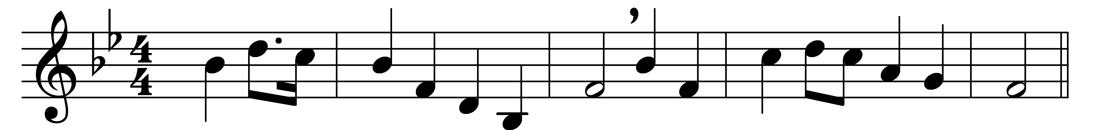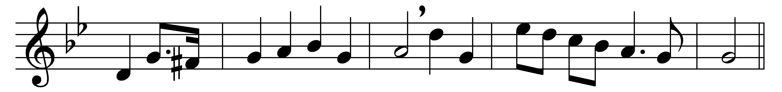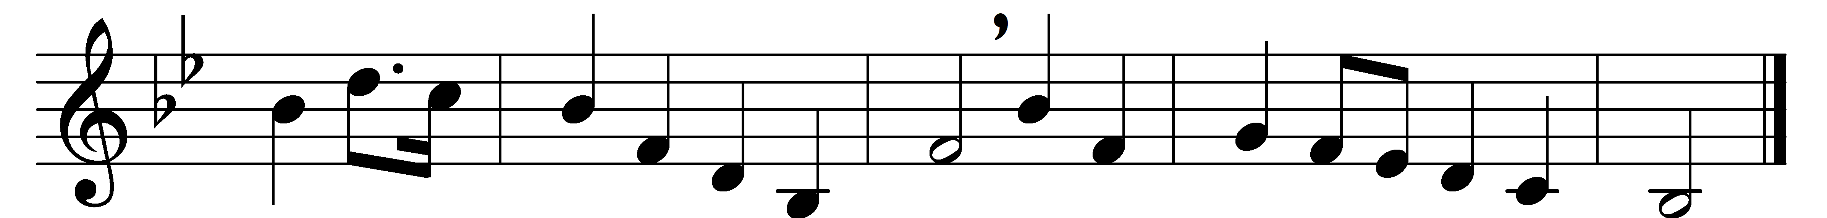

Sing, O sing, this blessèd morn,
unto us a child is born,
unto us a son is given,
God himself comes down from heaven.
Refrain:
Sing, O sing, this blessèd morn,
Jesus Christ today is born.

God from God, and Light from Light,
comes with mercies infinite,
from high heaven he comes to earth,
one with us in human birth.
Refrain

God with us, Emmanuel,
deigns for ever now to dwell;
he on Adam’s fallen race
sheds the fulness of his grace.
Refrain

God comes down that we may rise,
lifted by him to the skies;
Christ is born for us that we
born again in him may be.
Refrain

O renew us, Lord, we pray,
with thy Spirit day by day,
that we ever one may be
with the Father and with thee.
Refrain

Words: Christopher Wordsworth (1807-1885)
Music: Adapted from an English melody by Geoffrey Turton Shaw (1879-1943)

