Love came down at Christmas Hymnal 1982 no. 84 Melody: Gartan 6 7. 6 7.

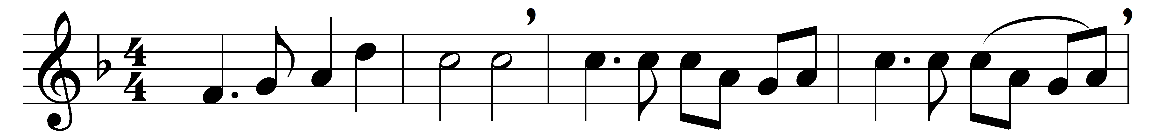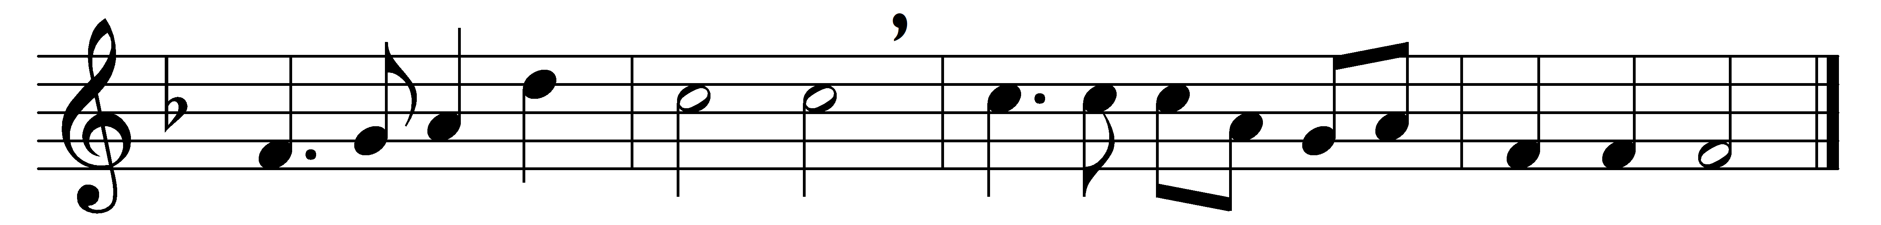

Love came down at Christmas,
love all lovely, love divine;
love was born at Christmas:
star and angels gave the sign.

Worship we the Godhead,
love incarnate, love divine;
worship we our Jesus,
but wherewith for sacred sign?

Love shall be our token;
love be yours and love be mine,
love to God and neighbor,
love for plea and gift and sign.

Words: Christina Rossetti (1830-1894)
Music: Melody from Petrie Collection of Irish Melodies, Part II, 1902, harmonised by David Evans (1874-1948)

