From east to west, from shore to shore Hymnal 1982 no. 77
Melody: Vom Himmel kam der Engel Schar L.M.

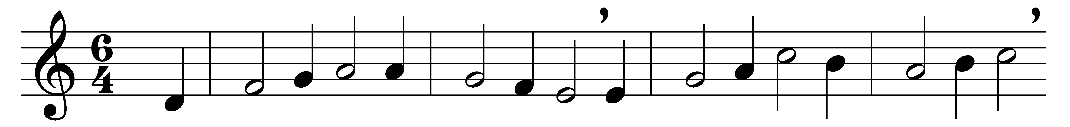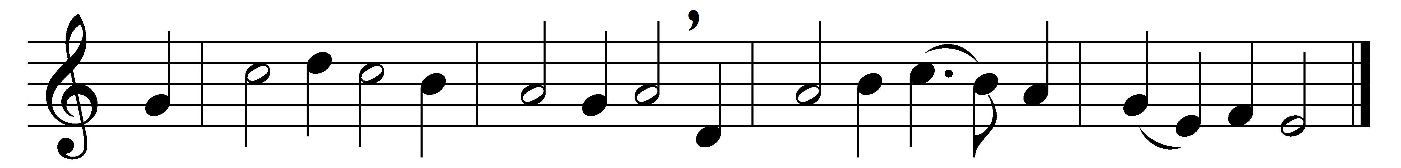

From east to west, from shore to shore,
let every heart awake and sing
the holy child whom Mary bore,
the Christ, the everlasting King.

Behold, the world’s creator wears
the form and fashion of a slave;
our very flesh our Maker shares,
his fallen creatures all to save.

For this how wondrously he wrought!
A maid in lowly human place
became, in ways beyond all thought,
the chosen vessel of his grace.

And while the angels in the sky
sang praise above the silent field,
to shepherds poor the Lord Most High,
the one great Shepherd, was revealed.

All glory for this blessed morn
to God the Father ever be;
all praise to thee, O Virgin-born,
all praise, O Holy Ghost, to thee.

Words: Caelius Sedulius (5th century), translated by John Ellerton (1826-1893)
Music: Source of melody unknown

