Hark the glad sound! the Saviour comes Hymnal 1982 no. 72 Melody: Richmond C.M.
AMNS words
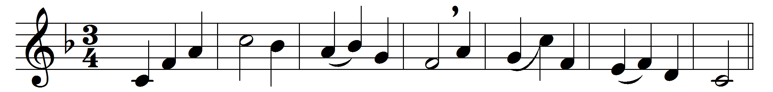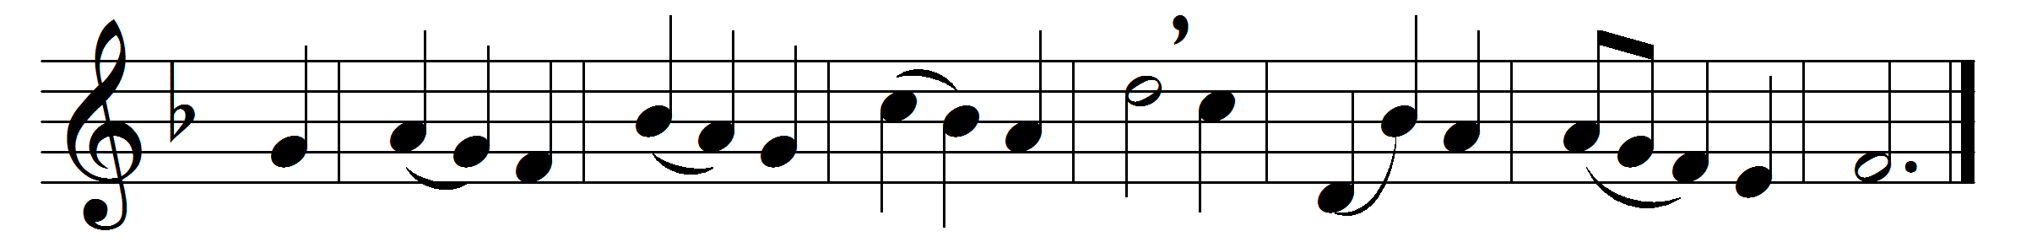

Hark the glad sound! the Saviour comes,
the Saviour promised long:
let every heart prepare a throne,
and every voice a song.

He comes, the prisoners to release
in Satan’s bondage held;
the gates of brass before him burst,
the iron fetters yield.

He comes, the broken heart to bind,
the bleeding soul to cure,
and with the treasures of his grace
to bless the humble poor.

Our glad hosannas, Prince of Peace,
thy welcome shall proclaim;
and heaven’s eternal arches ring
with thy belovèd name.

Words: Philip Doddridge (1702-1751)
Music: Melody adapted from Thomas Haweis (1734-1820) by Samuel Webbe (1740-1816)

