Hark! the glad sound! the Savior comes Hymnal 1982 no. 72 Melody: Richmond C.M.

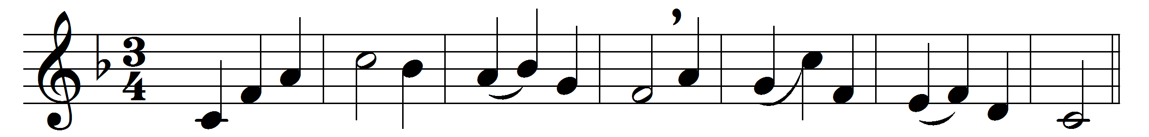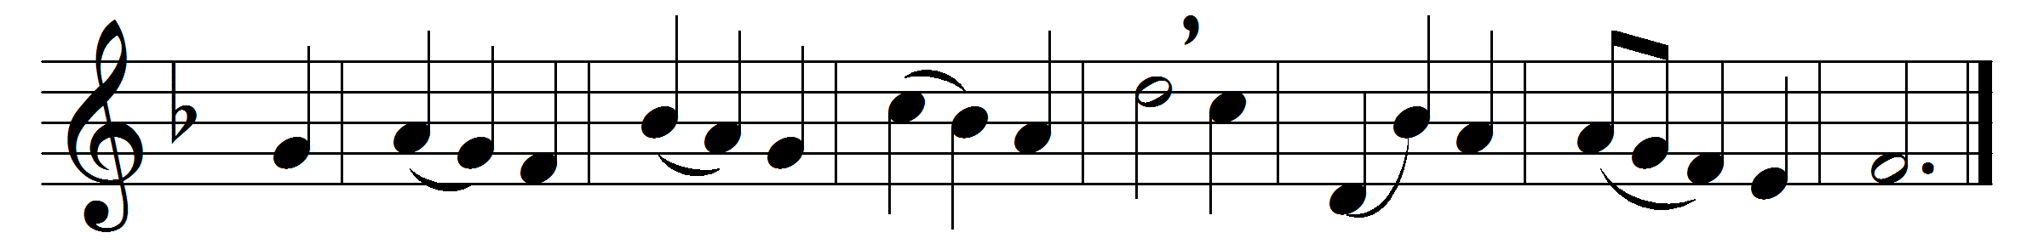

Hark! the glad sound! the Savior comes,
the Savior promised long;
let every heart prepare a throne,
and every voice a song.

He comes, the prisoners to release
in Satan’s bondage held;
the gates of brass before him burst,
the iron fetters yield.

He comes, the broken heart to bind,
the bleeding soul to cure;
and with the treasures of his grace
to enrich the humble poor.

Our glad hosannas, Prince of Peace,
thy welcome shall proclaim;
and heaven’s eternal arches ring
with thy belovèd name.

Words: Philip Doddridge (1702-1751)
Music: Melody adapted from Thomas Haweis (1734-1820) by Samuel Webbe (1740-1816)

