My country, ’tis of thee Hymnal 1982 no. 717 Melody: America 6 6 4. 6 6 6 4.
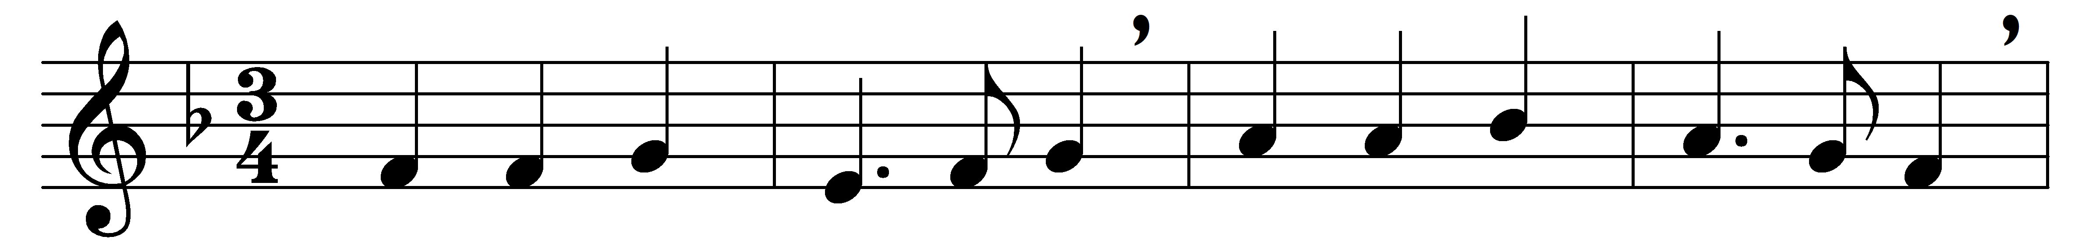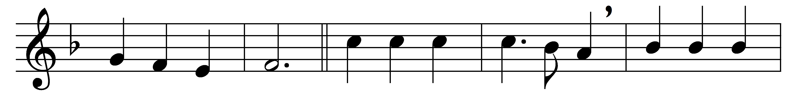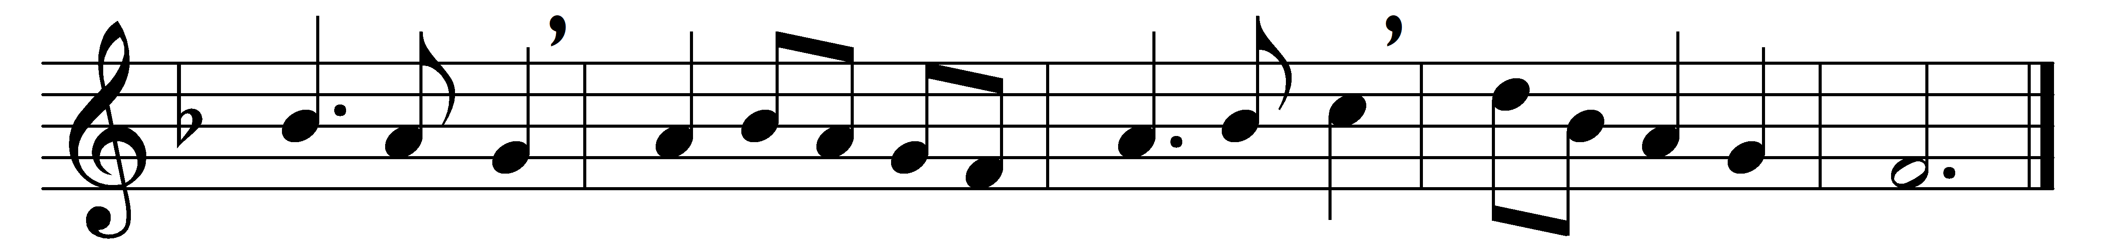

My country, ’tis of thee,
sweet land of liberty,
of thee I sing;
land where my fathers died,
land of the pilgrim’s pride,
from every mountainside
let freedom ring.

My native country, thee,
land of the noble free,
thy name I love;
I love thy rocks and rills,
thy woods and templed hills;
my heart with rapture thrills
like that above.

Let music swell the breeze,
and ring from all the trees
sweet freedom’s song;
let mortal tongues awake,
let all that breathe partake,
let rocks their silence break,
the sound prolong.

Our fathers’ God, to thee,
author of liberty,
to thee we sing;
long may our land be bright
with freedom’s holy light;
protect us by thy might,
great God, our King.

Words: Samuel Francis Smith (1808-1895)
Music: Thesaurus Musicus, c. 1743

