O God of Bethel, by whose hand Hymnal 1982 no. 709 Melody: Dundee C.M.
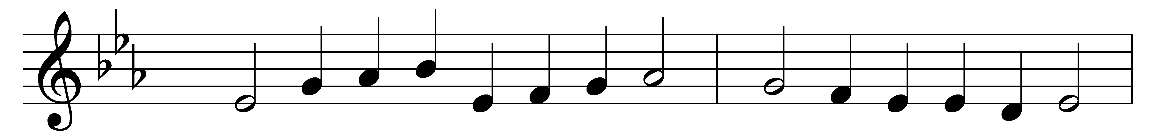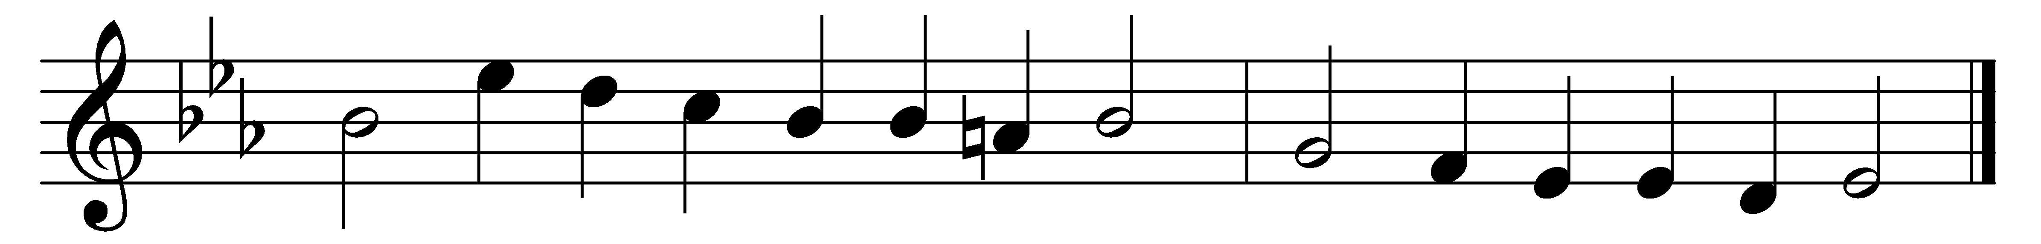

O God of Bethel, by whose hand
thy people still are fed;
who through this earthly pilgrimage
hast all our fathers led:

Our vows, our prayers, we now present
before thy throne of grace:
O God of Israel, be the God
of this succeeding race.

Through each perplexing path of life
our wandering footsteps guide;
give us each day our daily bread,
and raiment fit provide.

O spread thy covering wings around,
till all our wanderings cease,
and at our Father’s loved abode
our souls arrive in peace!

Such blessings from thy gracious hand
our humble prayers implore;
and thou shalt be our covenant God
and portion evermore.

Words: Philip Doddridge (1702-1751)
Music: Melody from Psalms (Edinburgh, 1615), harmony by Thomas Ravenscroft (1592?-1635?)

