Take my life, and let it be Hymnal 1982 no. 707 Melody: Aberystwyth 7 7. 7 7. D.
Words from AMNS
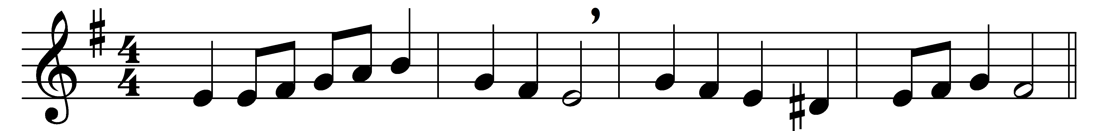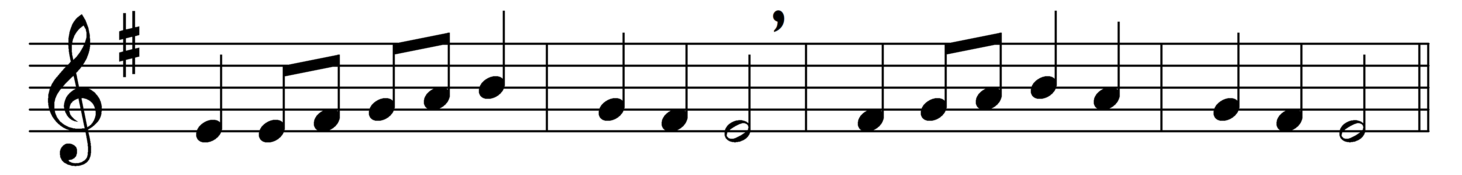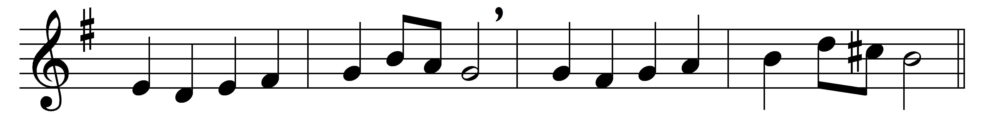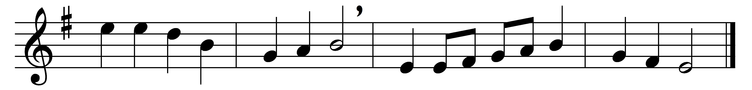

Take my life, and let it be
consecrated, Lord, to thee;
take my moments and my days,
let them flow in ceaseless praise.

Take my hands, and let them move
at the impulse of thy love;
take my feet, and let them be
swift and beautiful for thee.

Take my voice, and let me sing
always, only, for my King;
take my lips, and let them be
filled with messages from thee.

Take my silver and my gold;
not a mite would I withhold;
take my intellect, and use
every power as thou shalt choose.

Take my will, and make it thine:
it shall be no longer mine;
take my heart: it is thine own;
it shall be thy royal throne.

Take my love; my Lord, I pour
at thy feet its treasure-store;
take myself, and I will be
ever, only, all for thee.

Words: Frances Ridley Havergal (1836-1879)
Music: Joseph Parry (1841-1903)

