My God, accept my heart this day Hymnal 1982 no. 697 Melody: Song 67 C.M.
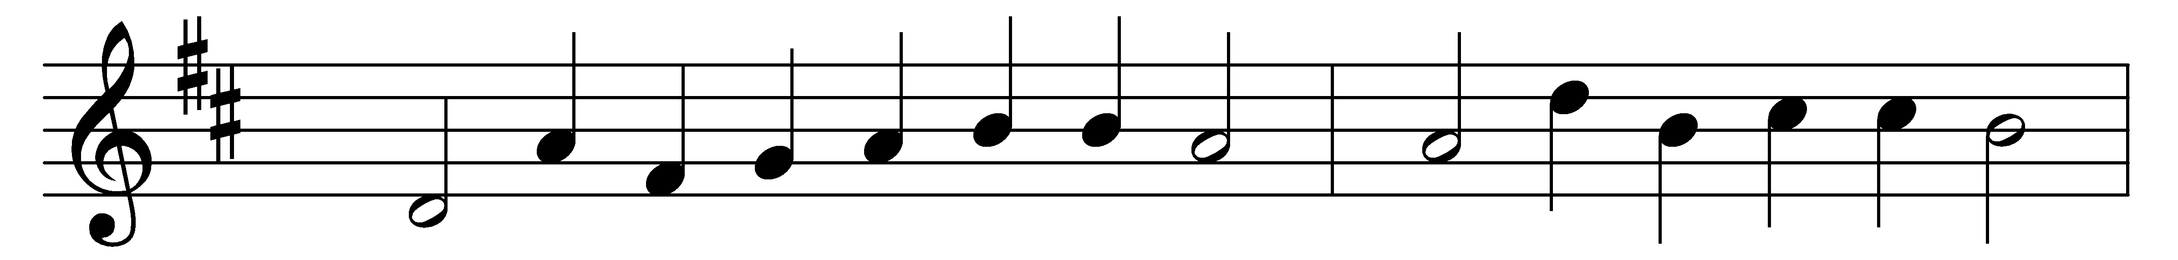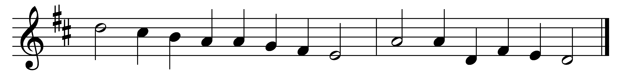

My God, accept my heart this day,
and make it always thine,
that I from thee no more may stray,
no more from thee decline.

Before the cross of him who died,
behold, I prostrate fall;
let every sin be crucified,
and Christ be all in all.

Anoint me with thy heavenly grace,
and seal me for thine own,
that I may see thy glorious face,
and worship near thy throne.

Let every thought and work and word,
to thee be ever given;
then life shall be thy service, Lord,
and death the gate of heaven.

Words: Matthew Bridges (1800-1894)
Music: Melody from Llyfr y Psalmau, 1621, adapted by Orlando Gibbons (1583-1625), harmony by Mary Monica Waterhouse Bridges (1863-1949), altered by Charles Winfred Douglas (1867-1944)

