O for a closer walk with God Hymnal 1982 no. 683 Melody: Beatitudo C.M.
Words from AMNS
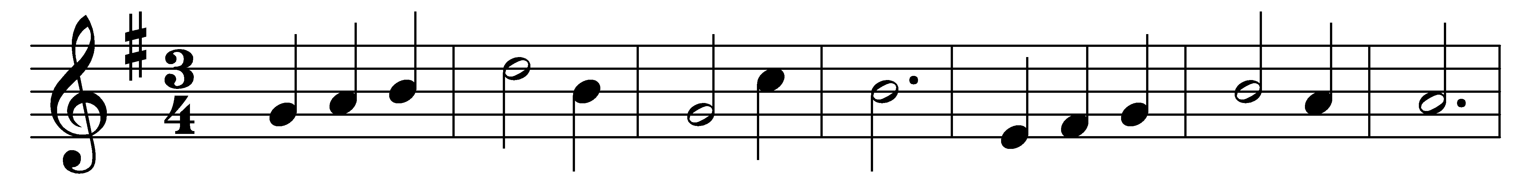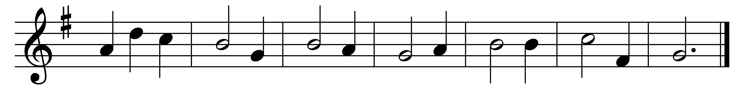

O for a closer walk with God,
a calm and heavenly frame;
a light to shine upon the road
that leads me to the Lamb.
What peaceful hours I once enjoyed,
how sweet their memory still!
but they have left an aching void
the world can never fill.
Return, O holy Dove, return,
sweet messenger of rest:
I hate the sins that made thee mourn,
and drove thee from my breast.
The dearest idol I have known,
whate’er that idol be,
help me to tear it from thy throne,
and worship only thee.
So shall my walk be close with God,
calm and serene my frame;
so purer light shall mark the road
that leads me to the Lamb.

Words: William Cowper (1731-1800)
Music: John Bacchus Dykes (1823-1876)

