I love thee, Lord, but not because Hymnal 1982 no. 682 Melody: St Fulbert C.M.

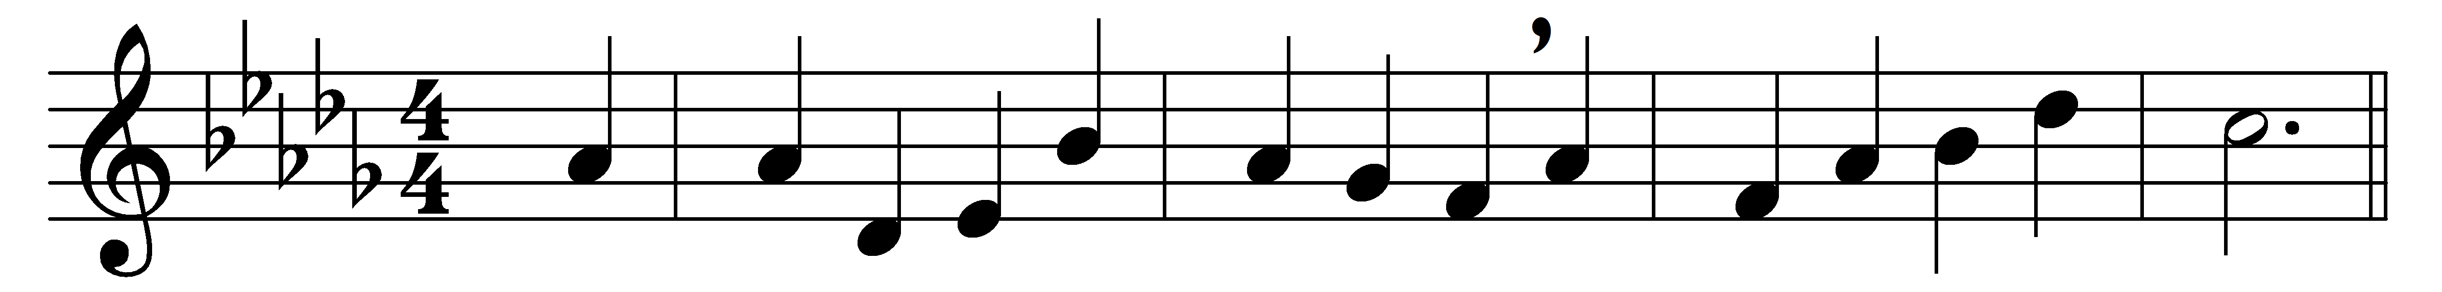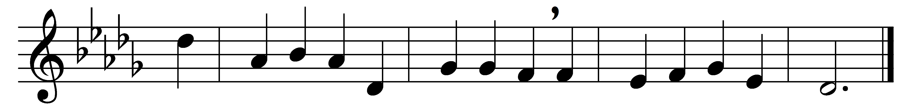

I love thee, Lord, but not because
I hope for heaven thereby,
nor yet for fear that loving not
I might for ever die;

but for that thou didst all the world
upon the cross embrace;
for us didst bear the nails and spear,
and manifold disgrace,

and griefs and torments numberless,
and sweat of agony;
e’en death itself; and all for one
who was thine enemy.

Then why, most loving Jesus Christ,
should I not love thee well,
not for the sake of winning heaven,
nor any fear of hell;

not with the hope of gaining aught,
not seeking a reward;
but as thyself hast lovèd me,
O ever loving Lord!

E’en so I love thee, and will love,
and in thy praise will sing,
solely because thou art my God
and my eternal King.

Words: Latin, 17th century, translated by Edward Caswall (1814-1878), adapted by Percy Dearmer (1867-1936)
Music: Henry John Gauntlett (1805-1876)

