O very God of very God Hymnal 1982 no. 672 Melody: Bangor C.M.
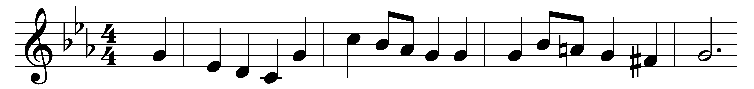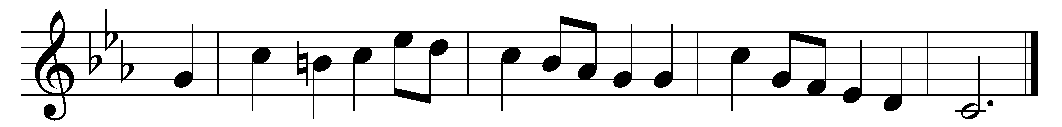

O very God of very God,
and very Light of Light,
whose feet this earth’s dark valley trod
that so it might be bright:

Our hopes are weak, our fears are strong,
thick darkness blinds our eyes;
cold is the night; thy people long
that thou, their Sun, wouldst rise.

And even now, though dull and gray,
the east is brightening fast,
and kindling to the perfect day
that never shall be past.

O guide us till our path is done,
and we have reached the shore
where thou, our everlasting Sun,
art shining evermore!

We wait in faith, and turn our face
to where the daylight springs,
till thou shalt come our gloom to chase,
with healing in thy wings.

Words: John Mason Neale (1818-1866)
Music: From A Compleat Melody or Harmony of Zion, 1734

