Amazing grace! how sweet the sound Hymnal 1982 no. 671 Melody: New Britain C.M.
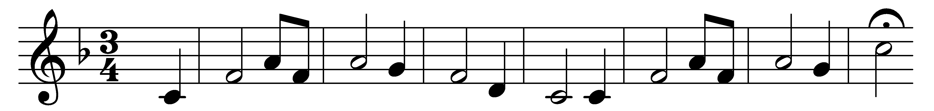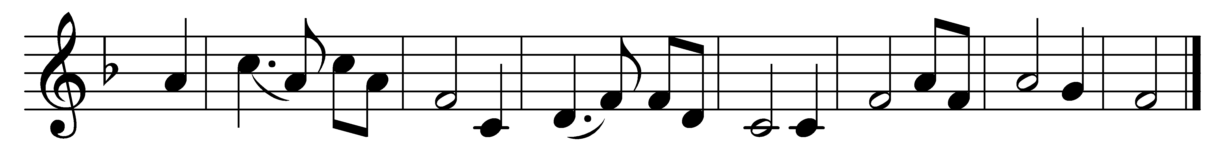

Amazing grace! how sweet the sound
that saved a wretch like me!
I once was lost but now am found,
was blind but now I see.

’Twas grace that taught my heart to fear,
and grace my fears relieved;
how precious did that grace appear
the hour I first believed!

The Lord has promised good to me,
his word my hope secures;
he will my shield and portion be
as long as life endures.

Through many dangers, toils, and snares,
I have already come;
’tis grace that brought me safe thus far,
and grace will lead me home.

When we’ve been there ten thousand years,
bright shining as the sun,
we’ve no less days to sing God’s praise
than when we’d first begun.

Words: John Newton (1725-1807), v. 5 by John Rees (19th century)
Music: Melody from Virginia Harmony, 1831, adaptation attributed to Edwin Othello Excell (1851-1921)

