Out of the depths I call Hymnal 1982 no. 666 Melody: Southwell (Damon) S.M.
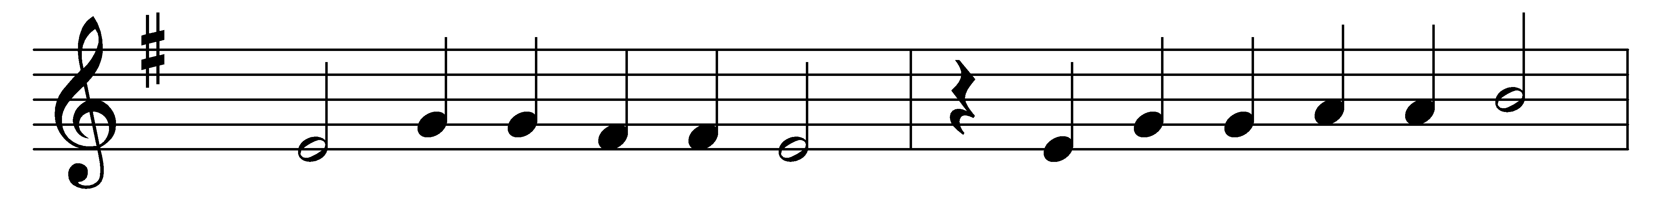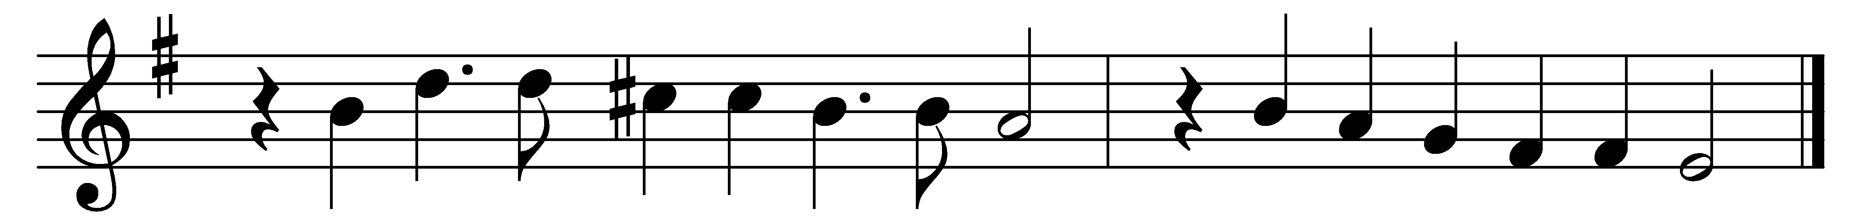

Out of the depths I call,
to God I send my cry;
Lord, hear my supplicating voice
and graciously reply.

My soul with patience waits
for thee, the living Lord,
my hopes are on thy promise built,
thy never-failing word.

My longing eyes look out
for thy enlivening ray,
more duly than the morning watch
to spy the dawning day.

Let Israel trust in God;
no bounds his mercy knows;
the plenteous source and spring from whence
redemption ever flows.

Words: From A Supplement to the New Version of the Psalms, 1698
Music: From Daman’s Psalter, 1579

