My shepherd will supply my need Hymnal 1982 no. 664 Melody: Resignation D.C.M.
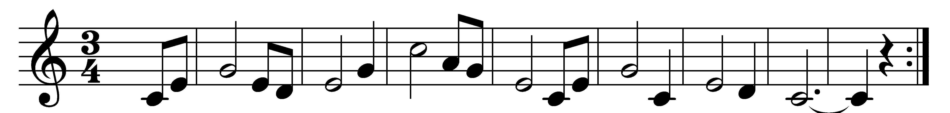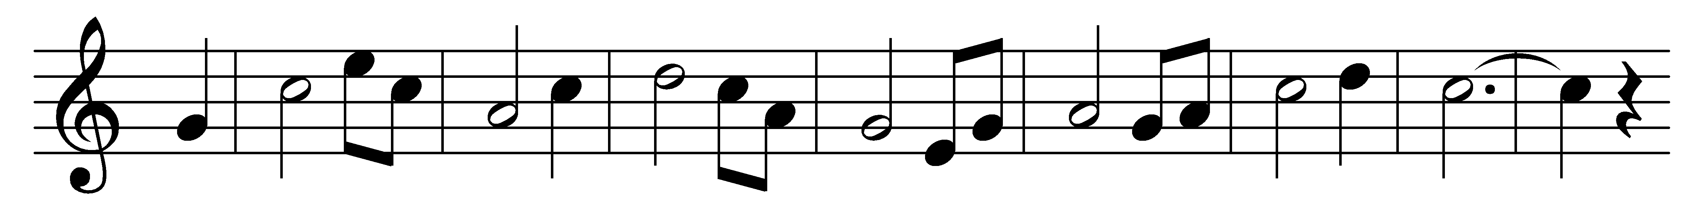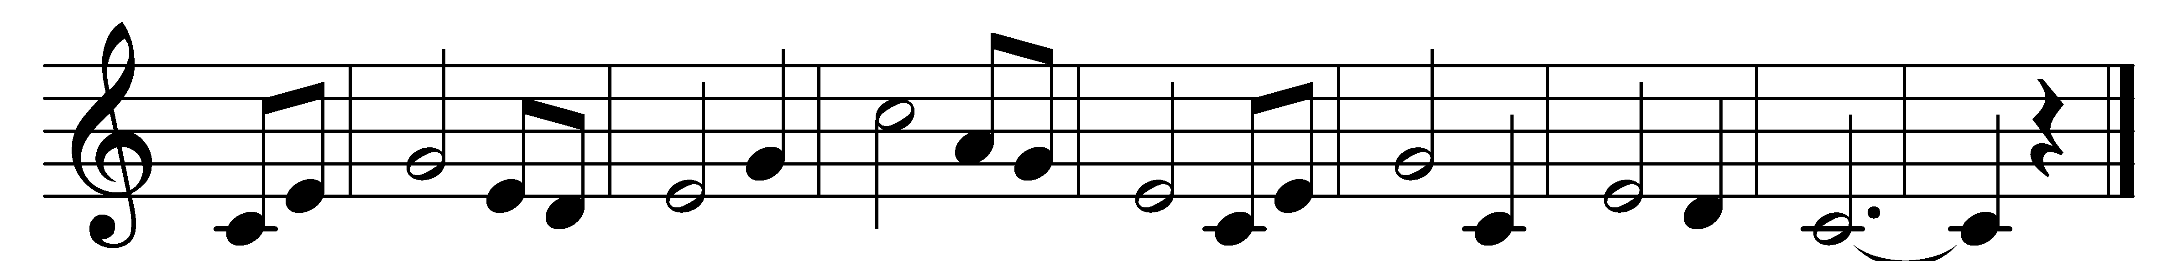

My Shepherd will supply my need,
Jehovah is his Name;
in pastures fresh he makes me feed
beside the living stream.
He brings my wandering spirit back
when I forsake his ways,
and leads me, for his mercy’s sake,
in paths of truth and grace.

When I walk through the shades of death,
thy presence is my stay;
one word of thy supporting breath
drives all my fears away.
Thy hand, in sight of all my foes,
doth still my table spread;
my cup with blessings overflows,
thy oil anoints my head.

The sure provisions of my God
attend me all my days;
oh, may thy house be mine abode,
and all my work be praise.
There would I find a settled rest,
while others go and come;
no more a stranger or a guest,
but like a child at home.

Words: Isaac Watts (1674-1748)
Music: American folk melody

