Day by day Hymnal 1982 no. 654 Melody: Sumner Irregular

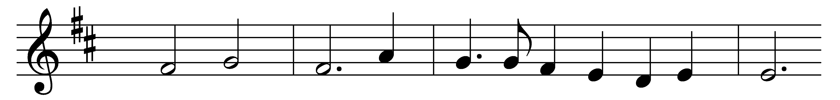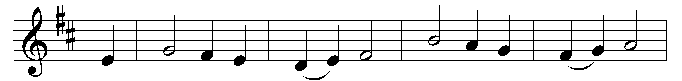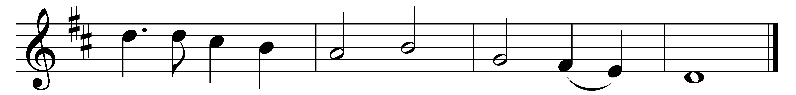

Day by day, dear Lord, of thee three things I pray:

to see thee more clearly, love thee more dearly,

follow thee more nearly, day by day.

Words: Attributed to Richard of Chichester (1197-1253)

Music: Arthur Henry Biggs (1906-1954)