O Jesus, joy of loving hearts Hymnal 1982 no. 650 Melody: Jesu dulcis memoria L.M.
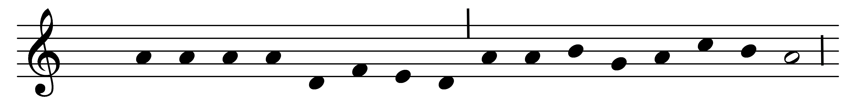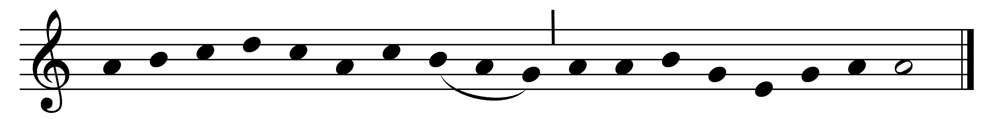

O Jesus, joy of loving hearts,
the fount of life and our true light,
we seek the peace your love imparts
and stand rejoicing in your sight.

We taste in you our living bread,
and long to feast upon you still;
we drink of you, the fountainhead,
our thirsting souls to quench and fill.

For you our restless spirits yearn
where’er our changing lot is cast;
glad, when your presence we discern,
blest, when our faith can hold you fast.

O Jesus, ever with us stay;
make all our moments calm and bright;
oh, chase the night of sin away,
shed o’er the world your holy light.

Words: Bernard of Clairvaux (1091-1153), translated by Ray Palmer (1808-1887)
Music: Mode ii

