When Israel was in Egypt’s land Hymnal 1982 no. 648
Melody: Go Down, Moses 8 5. 8 5. with refrain
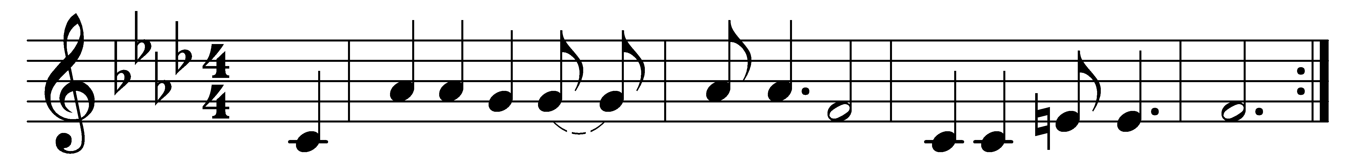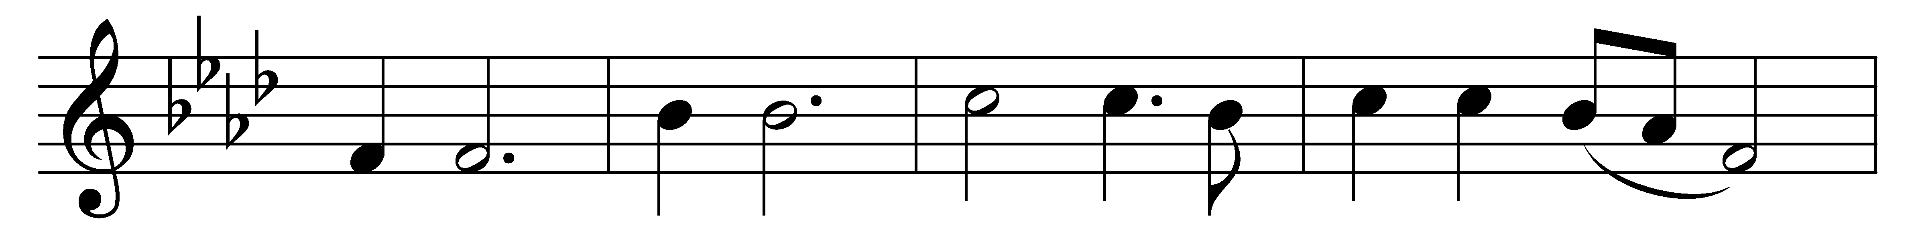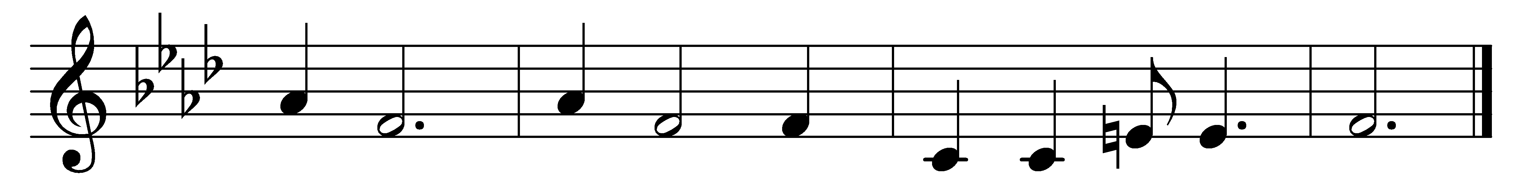

When Israel was in Egypt’s land,
let my people go;
oppressed so hard they could not stand,
let my people go.
(Refrain:) Go down, Moses,
way down in Egypt’s land;
tell old Pharaoh
to let my people go.

The Lord told Moses what to do,
let my people go;
to lead the children of Israel through,
let my people go. (Refrain)

They journeyed on at his command,
let my people go;
and came at length to Canaan’s land,
let my people go. (Refrain)

Oh, let us all from bondage flee,
let my people go;
and let us all in Christ be free,
let my people go. (Refrain)

Words: Afro-American spiritual
Music: Afro-American spiritual

