My God, how wonderful thou art 1982 no. 643 Melody: Windsor C.M.
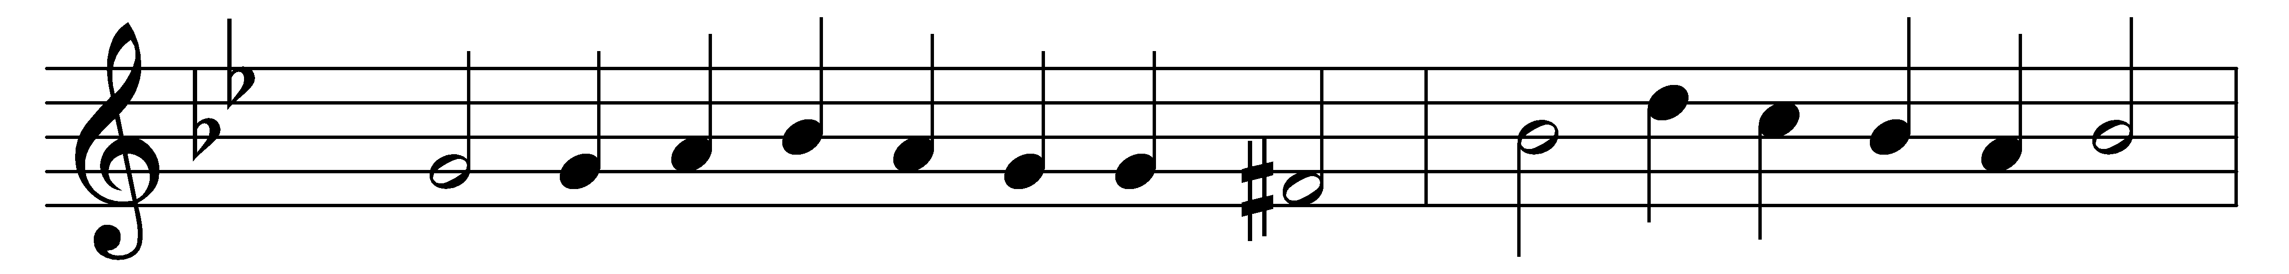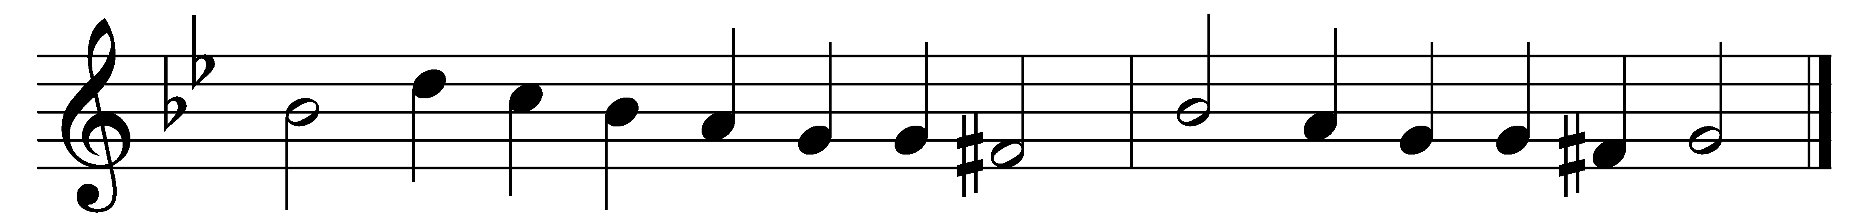

My God, how wonderful thou art,
thy majesty how bright,
how beautiful thy mercy seat,
in depths of burning light!

How dread are thine eternal years,
O everlasting Lord,
by prostrate spirits day and night
incessantly adored!

How wonderful, how beautiful,
the sight of thee must be,
thine endless wisdom, boundless power,
and aweful purity!

O how I fear thee, living God,
with deepest, tenderest fears,
and worship thee with trembling hope
and penitential tears!

Yet I may love thee too, O Lord,
almighty as thou art,
for thou hast stooped to ask of me
the love of my poor heart.

Words: Frederick William Faber (1814-1863)
Music: Melody by William Damon (1540?-1591?), harmony from Booke of Musicke, 1591

