Jesus, the very thought of thee 1982 no. 642 Melody: Windsor C.M.
Isometric (music from no. 643)
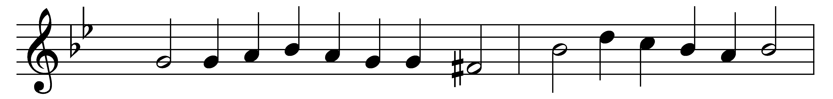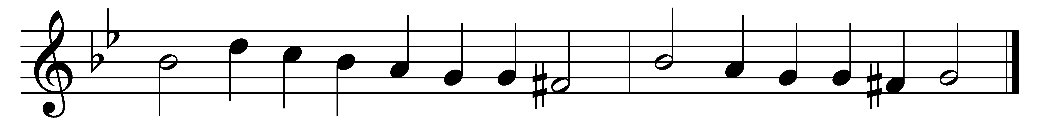

Jesus, the very thought of thee
with sweetness fills the breast;
but sweeter far thy face to see,
and in thy presence rest.

No voice can sing, no heart can frame,
nor can the memory find,
a sweeter sound than Jesus’ Name,
the Savior of mankind.

O hope of every contrite heart,
O joy of all the meek,
to those who fall, how kind thou art:
how good to those who seek!

But what to those who find? Ah, this
nor tongue nor pen can show;
the love of Jesus, what it is,
none but who love him know.

Jesus, our only joy be thou,
as thou our prize wilt be;
in thee be all our glory now,
and through eternity.

Words: Latin, c. 12th century, translated by Edward Caswall (1814-1878)
Music: Melody by William Damon (1540?-1591?), harmony from Booke of Musicke, 1591

