Lord Jesus, think on me Hymnal 1982 no. 641 Melody: Southwell (Damon) S.M.
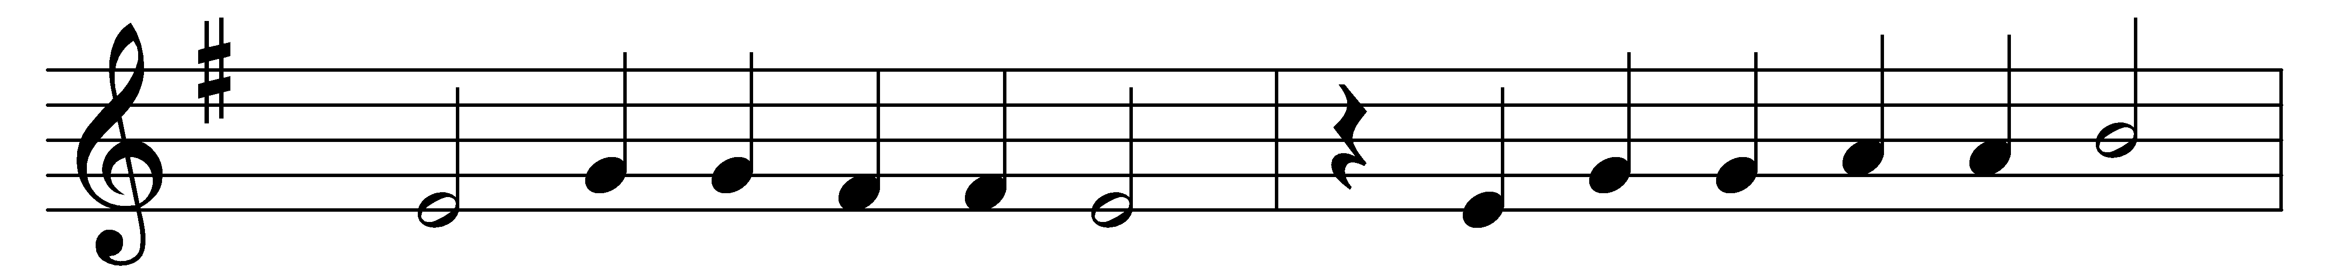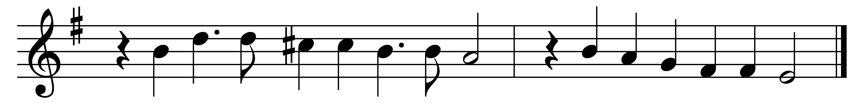

Lord Jesus, think on me,
and purge away my sin;
from harmful passions set me free,
and make me pure within.

Lord Jesus, think on me,
with care and woe oppressed;
let me thy loving servant be,
and taste thy promised rest.

Lord Jesus, think on me,
nor let me go astray;
through darkness and perplexity
point thou the heavenly way.

Lord Jesus, think on me,
that, when the flood is passed,
I may th’ eternal brightness see,
and share thy joy at last.

Words: Synesius of Cyrene (c. 375-c. 414), translated by Allen William Chatfield (1808-1896)
Music: Adapted from Daman’s Psalter, 1579

