Watchman, tell us of the night Hymnal 1982 no. 640 Melody: Aberystwyth 7 7. 7 7. D.
British spelling
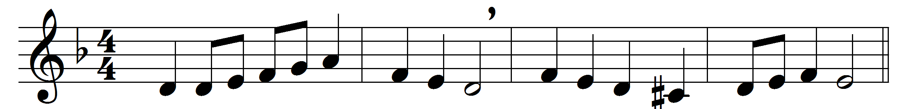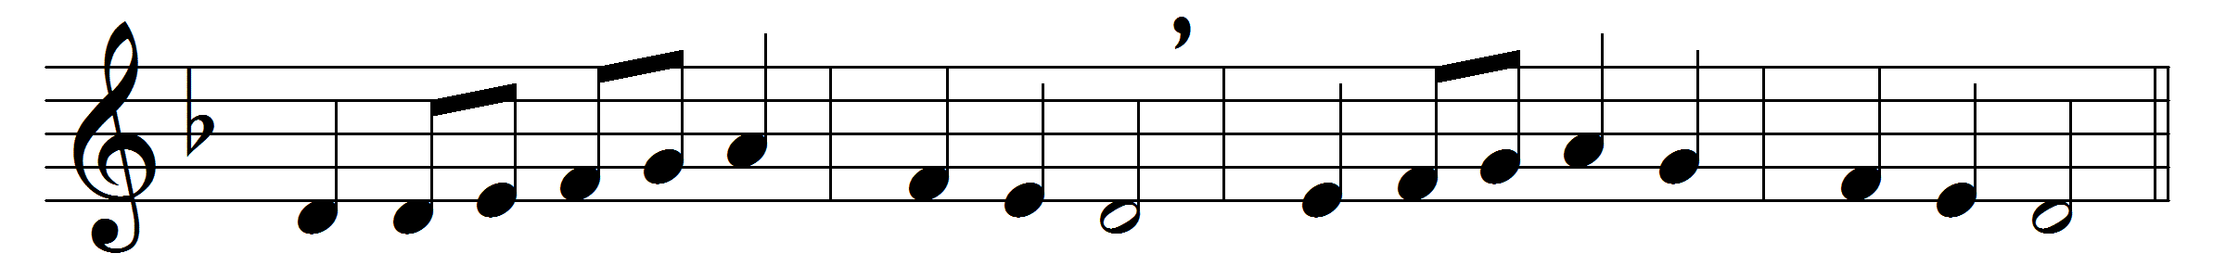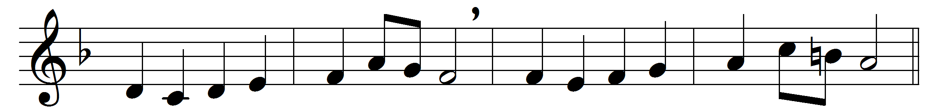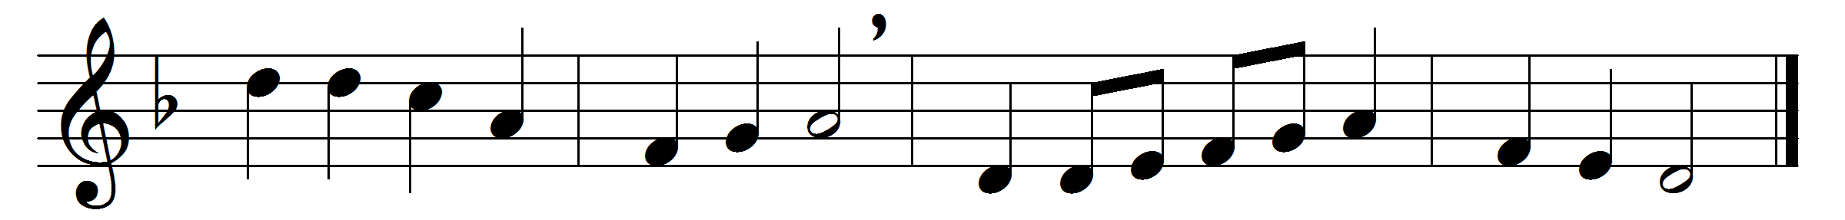

Watchman, tell us of the night,
what its signs of promise are.
Traveller, o’er yon mountain’s height,
see that glory-beaming star.
Watchman, does its beauteous ray
aught of joy or hope foretell?
Traveller, yes; it brings the day,
promised day of Israel.

Watchman, tell us of the night;
higher yet that star ascends.
Traveller, blessedness and light,
peace and truth its course portends.
Watchman, will its beams alone
gild the spot that gave them birth?
Traveller, ages are its own;
see, it bursts o’er all the earth.

Watchman, tell us of the night,
for the morning seems to dawn.
Traveller, darkness takes its flight,
doubt and terror are withdrawn.
Watchman, let thy wanderings cease;
hie thee to thy quiet home.
Traveller, lo! the Prince of Peace,
lo! the Son of God is come!

Words: John Bowring (1792-1872)
Music: Joseph Parry (1841-1903)

