Come, O thou Traveller unknown Hymnal 1982 no. 638 Melody: Vernon 8 8. 8 8. 8 8.
Words from AMNS
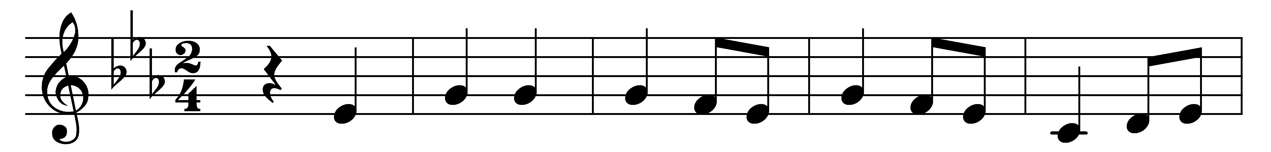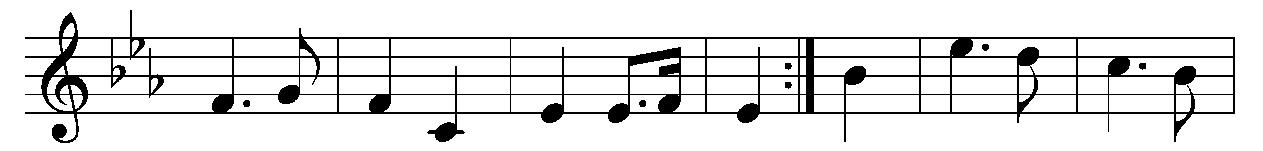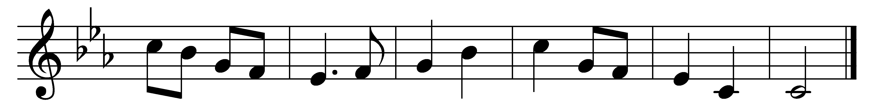

Come, O thou Traveller unknown,
whom still I hold, but cannot see;
my company before is gone,
and I am left alone with thee;
with thee all night I mean to stay,
and wrestle till the break of day.

I need not tell thee who I am,
my misery or sin declare;
thyself hast called me by my name;
look on thy hands, and read it there!
But who, I ask thee, who art thou?
tell me thy name, and tell me now.

In vain thou strugglest to get free;
I never will unloose my hold.
Art thou the man that died for me?
the secret of thy love unfold:
wrestling, I will not let thee go,
till I thy name, thy nature know.

Yield to me now, for I am weak,
but confident in self-despair;
speak to my heart, in blessings speak,
be conquered by my instant prayer.
Speak, or thou never hence shalt move,
and tell me if thy name is Love?

’Tis love! ’tis love! thou diedst for me!
I hear thy whisper in my heart!
the morning breaks, the shadows flee;
pure universal Love thou art:
to me, to all, thy mercies move;
thy nature and thy name is Love.

Words: Charles Wesley (1707-1788)
Music: Traditional melody, harmony attributed to Lucius Chapin (1760-1842)

