If thou but trust in God to guide thee Hymnal 1982 no. 635
Melody: Wer nur den lieben Gott 9 8. 9 8. 8 8.
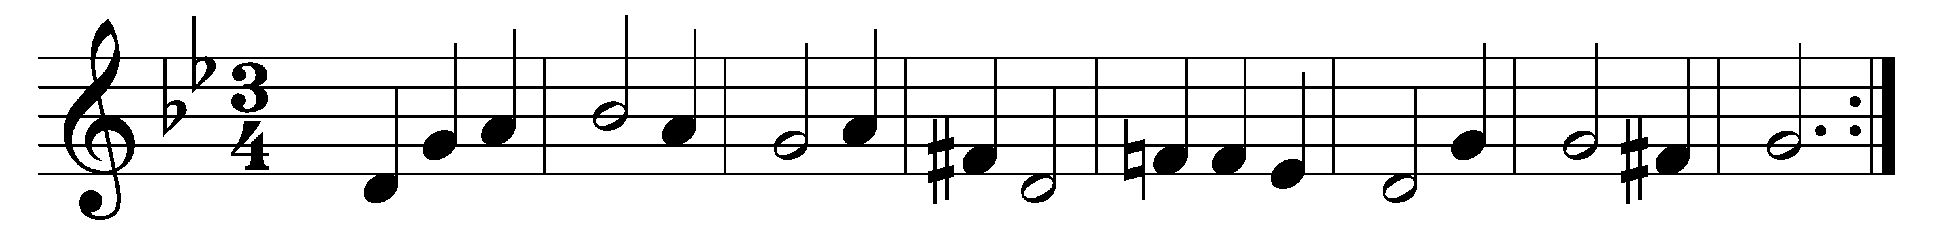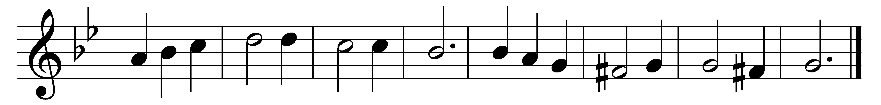

If thou but trust in God to guide thee,
and hope in him through all thy ways,
he’ll give thee strength whate’er betide thee,
and bear thee through the evil days.
Who trusts in God’s unchanging love
builds on a rock that nought can move.

Sing, pray, and keep his ways unswerving;
so do thine own part faithfully,
and trust his word, though undeserving;
thou yet shalt find it true for thee;
God never yet forsook in need
the soul that trusted him indeed.

Words: Georg Neumark (1621-1681), translated by Catherine Winkworth (1827-1878)
Music: Georg Neumark

