O Christ, the Word Incarnate Hymnal 1982 no. 632 Melody: Munich 7 6. 7 6. D.
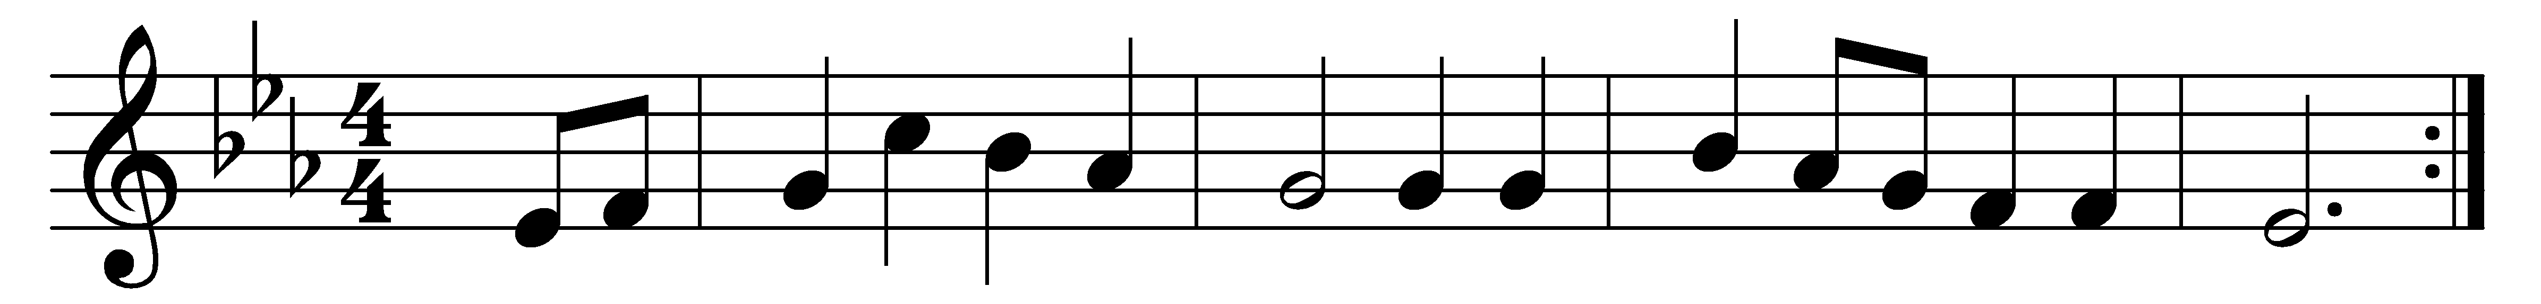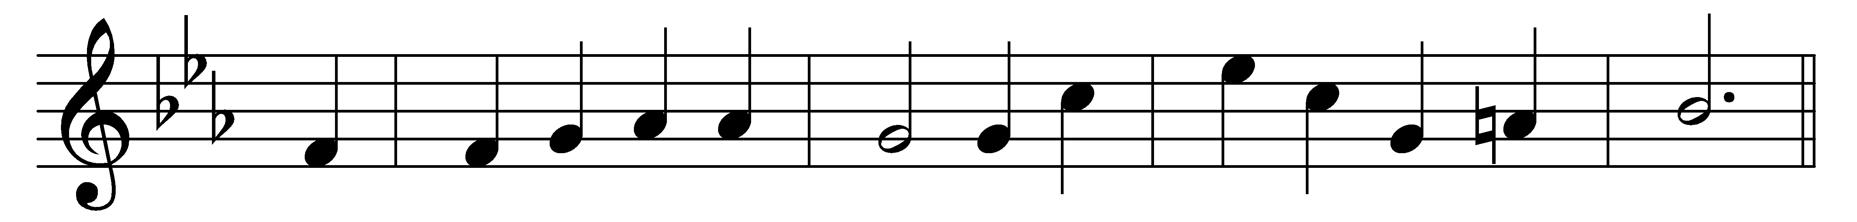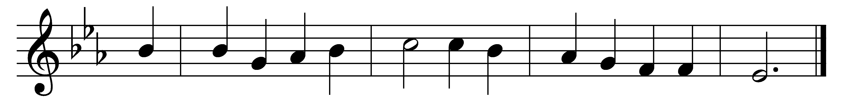

O Christ, the Word Incarnate,
O Wisdom from on high,
O Truth, unchanged, unchanging,
O Light of our dark sky;
we praise thee for the radiance
that from the scripture’s page,
a lantern to our footsteps,
shines on from age to age.

The Church from our dear Master
received the word divine,
and still that light is lifted
o’er all the earth to shine.
It is the chart and compass
that o’er life’s surging sea,
mid mists and rocks and quicksands,
still guides, O Christ, to thee.

O make thy Church, dear Savior,
a lamp of purest gold,
to bear before the nations
thy true light as of old;
O teach thy wandering pilgrims
by this their path to trace,
till, clouds and darkness ended,
they see thee face to face.

Words: William Walsham How (1823-1897)
Music: Melody from Neu-vermehrtes und zu Übung Christl. Gottseligkeit eingerichtetes Meiningisches Gesangbuch, 1693, adapted and harmonised by Felix Mendelssohn (1809-1847)

