Lamp of our feet, whereby we trace Hymnal 1982 no. 627 Melody: Nun danket all C.M.
British spelling
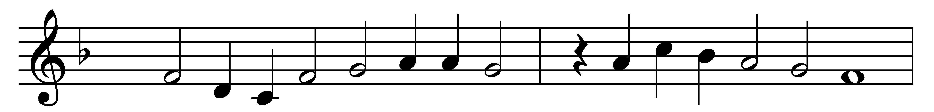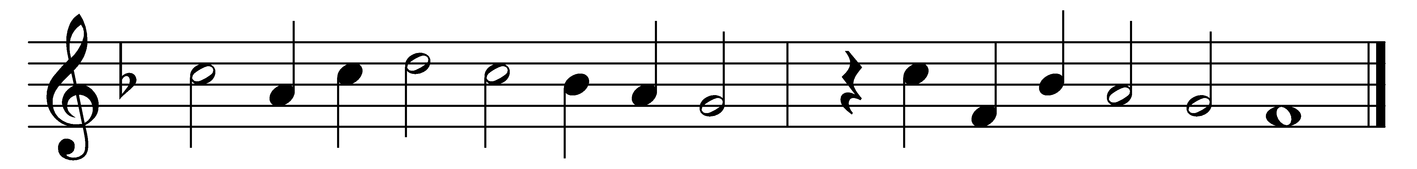

Lamp of our feet, whereby we trace
our path when wont to stray;
stream from the fount of heavenly grace,
brook by the traveller’s way;

bread of our souls, whereon we feed,
true manna from on high;
our guide and chart, wherein we read
of realms beyond the sky;

pillar of fire, through watches dark,
and radiant cloud by day;
when waves would whelm our tossing bark,
our anchor and our stay;

word of the ever-living God,
will of his glorious Son;
without thee how could earth be trod,
or heaven itself be won?

Lord, grant us all aright to learn
the wisdom it imparts;
and to its heavenly teaching turn,
with simple, childlike hearts.

Words: Bernard Barton (1784-1849)
Music: Melody from Praxis pietatis melica, 1647

