Hail to the Lord’s Anointed Hymnal 1982 no. 616
Melody: Es flog ein kleins Waldvögelein 7 6. 7 6. D.
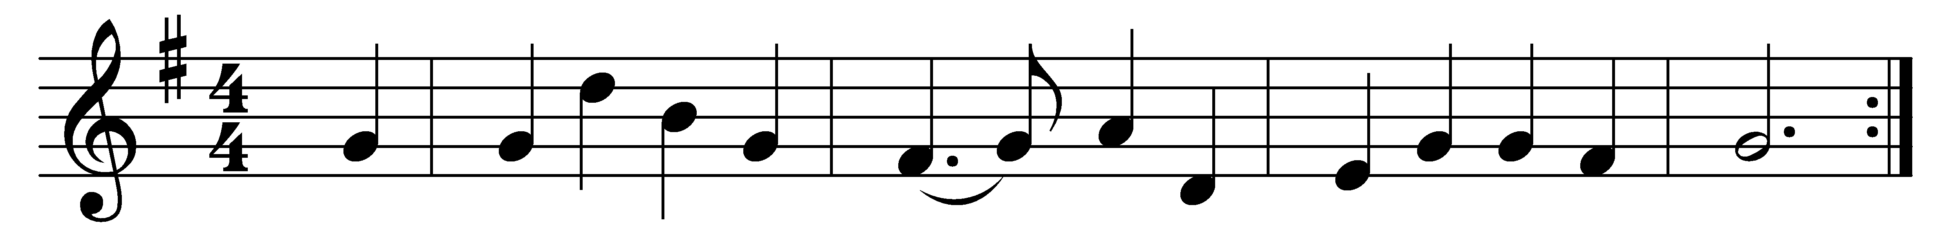

Hail to the Lord’s Anointed,
great David’s greater Son!
Hail, in the time appointed,
his reign on earth begun!
He comes to break oppression,
to set the captive free;
to take away transgression,
and rule in equity.

He comes with succor speedy
to those who suffer wrong,
to help the poor and needy,
and bid the weak be strong;
to give them songs for sighing,
their darkness turn to light,
whose souls, condemned and dying,
were precious in his sight.

He shall come down like showers
upon the fruitful earth,
and love, joy, hope, like flowers,
spring in his path to birth:
before him on the mountains
shall peace, the herald, go;
and righteousness in fountains
from hill to valley flow.

Kings shall bow down before him,
and gold and incense bring;
all nations shall adore him,
his praise all people sing;
to him shall prayer unceasing
and daily vows ascend;
his kingdom still increasing,
a kingdom without end.

O’er every foe victorious,
he on his thone shall rest;
from age to age more glorious,
all blessing and all blest:
the tide of time shall never
his covenant remove;
his Name shall stand for ever,
his changeless Name of Love.

Words: James Montgomery (1771-1854)
Music: German folk song, adaptation and harmony from A Student’s Hymnal, 1923, after Henry Walford Davies (1869-1941)

